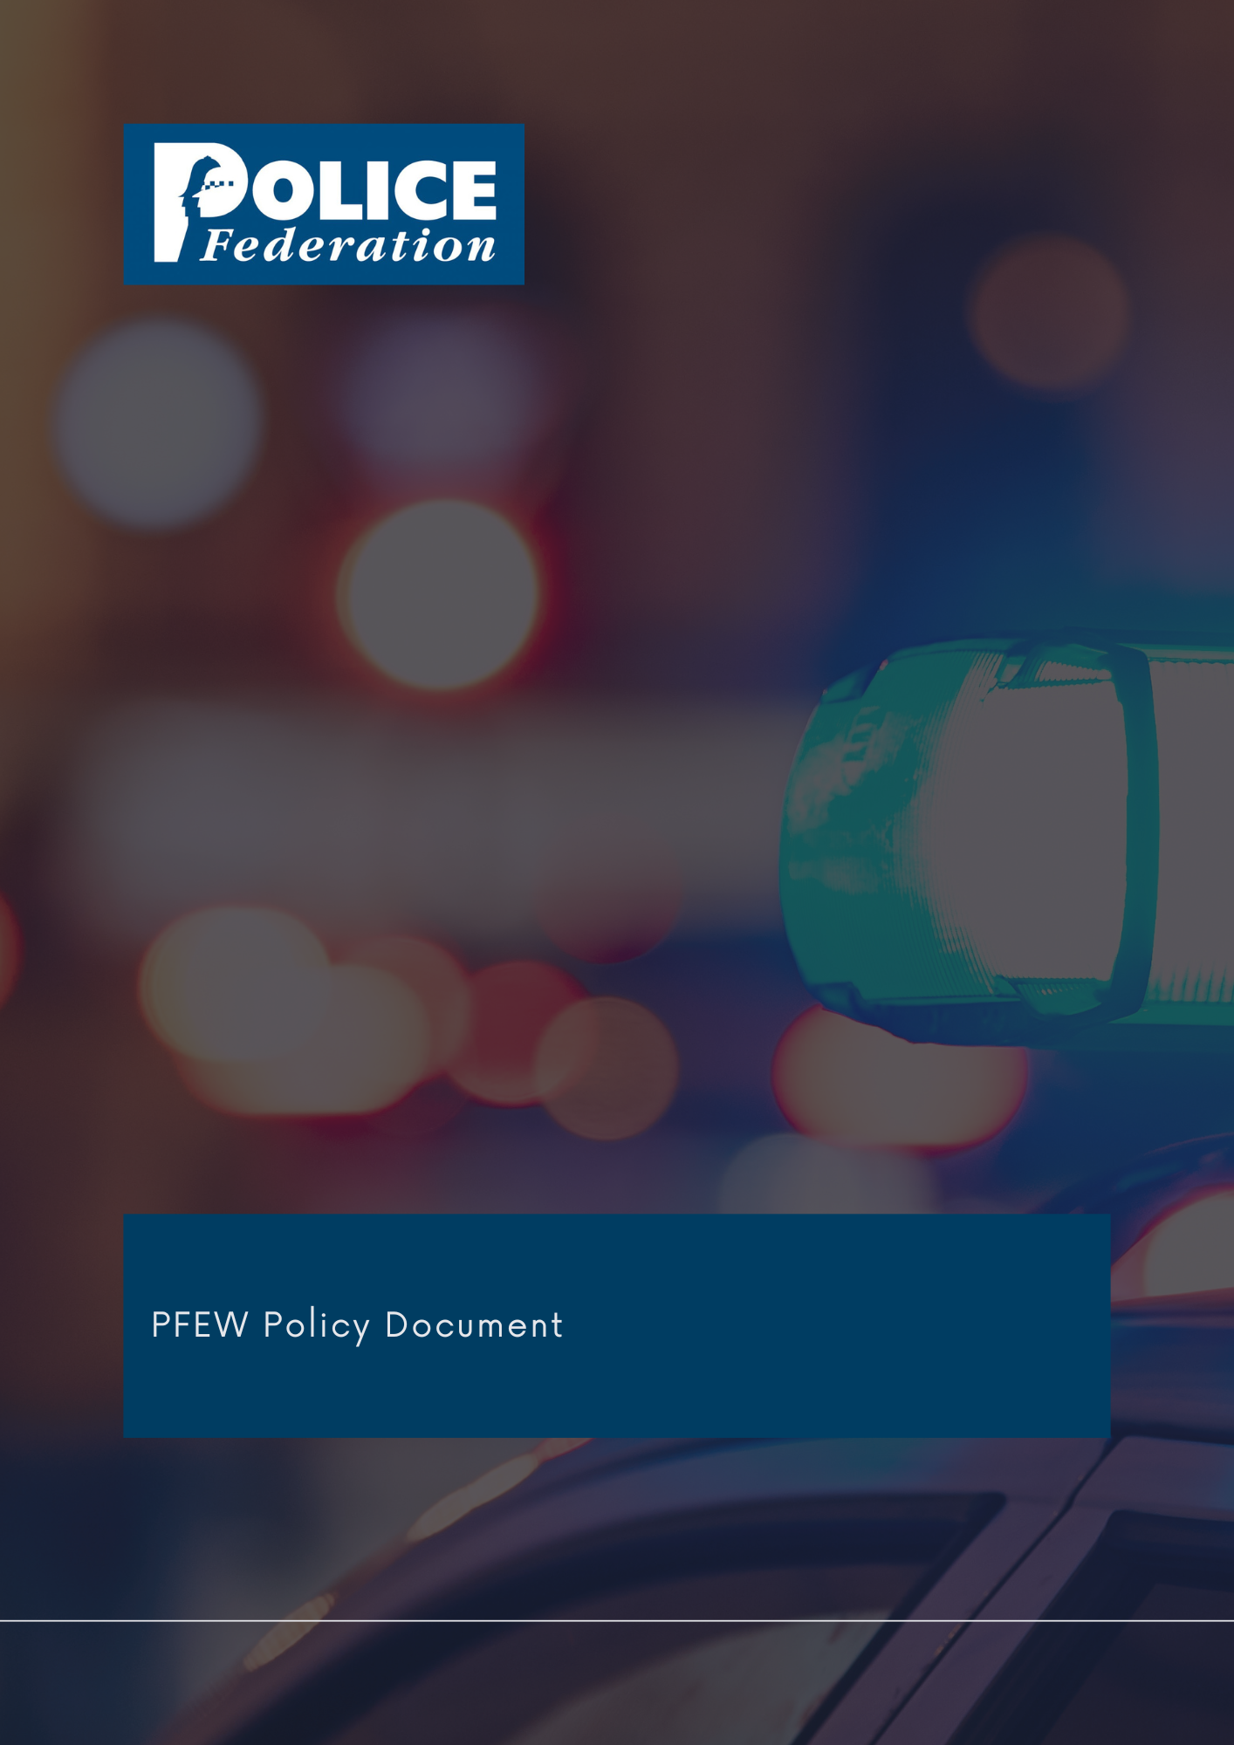
Drink Driving & Alcohol Limits Policy

Version 1
2023

The PFEW Policy Department has embarked on a programme to formulate and revise policy documents on matters of particular importance to its members.

It is the aim of PFEW to maintain clear policies on key topics that allow members to understand PFEW's official position on those areas.

These strategic documents are evidence-based, aligned with PFEW's Business Areas and championed by National Board members.

If you have any comments or queries, please direct them to Bahar.Munim@polfed.org

DRINK DRIVING & ALCOHOL LIMITS

1. Policy statement

Final estimates of casualties in accidents involving at least one driver or rider over the drink-drive limit in Great Britain for 2020 show that:
- between 200 and 240 people were killed in drink-drive accidents, with a central estimate of 220 fatalities
- the final estimate of fatalities for 2020 is broadly in line with the last few years and is not statistically significantly different from 2019
- an estimated 6,480 people were killed or injured in drink-drive accidents, a fall of 17% from 2019
- the central estimate of the number of killed or seriously injured (KSI adjusted) drink-drive casualties in 2020 is 1,490, a decrease of 22% on 2019

There are still too many people killed or injured as a result of drink driving and PFEW believes that the Government should reduce alcohol limits for drivers in England and Wales. This would bring England and Wales in line with Scotland and most other European countries, would potentially save lives and make roads in England and Wales safer. Drink driving is one symptom of heavier alcohol consumption. A report by the Organisation for Economic Co-operation and Development (OECD) in May 2015 found that levels of alcohol consumption in the UK are above the OECD average and have increased during the last 30 years. Heavy alcohol consumption impacts on NHS England and NHS Wales as well as it being a major factor in violent crime, domestic violence, and assaults on police officers.

2. Responsibility
The National Board is responsible for all policy formation.

3. Summary

Legal Limits
In England and Wales, the current alcohol limit for drivers is 80 milligrams of alcohol per 100
millilitres of blood, 35 micrograms per 100 millilitres of breath or 107 milligrams per 100millilitres of urine. In most other European countries, the limit is less. The risk of being involved in an accident increase concurrently with increased consumption of alcohol as alcohol impairs driving. The amount of alcohol a driver would need to drink to be considered over the limit varies from person to person depending on weight, gender, metabolism, the type and amount of alcohol being drunk, stress levels, whether food has been eaten and age. In order to deter drivers from drinking and driving PFEW calls on the Government to reduce the alcohol limits in England and Wales, and mirror that of Scotland, to 50 milligrams of alcohol in every 100 millilitres of blood, 22 micrograms of alcohol per 100 millilitres of breath and 67 milligrams of alcohol per 100 millilitres of urine. This would amount to a reduction for each measure of around 37%.

PFEW believes that Chief Officers should put roads policing back on the policing agenda and made a priority at national and local level. This combined with a lower alcohol limit will enable officers, the Crown Prosecution Service, and the courts to take more drivers off the road who pose a risk to public safety.

4. Procedures/implementation
PFEW will press the Government to reduce alcohol limits for drivers in England and Wales. We will campaign to have roads policing put back on the policing agenda and made a priority both nationally and locally.

Responsibility for maintaining this policy is delegated to the National Secretary and/or the appropriate business area.

Approved by National Board: June 2023
Review: June 2024

Source: DoT report 28/07/2022
Tackling Harmful Alcohol Use: Economics and Public Health Policy, OECD, May 2015
The drink drive limit - GOV.UK (www.gov.uk)

