
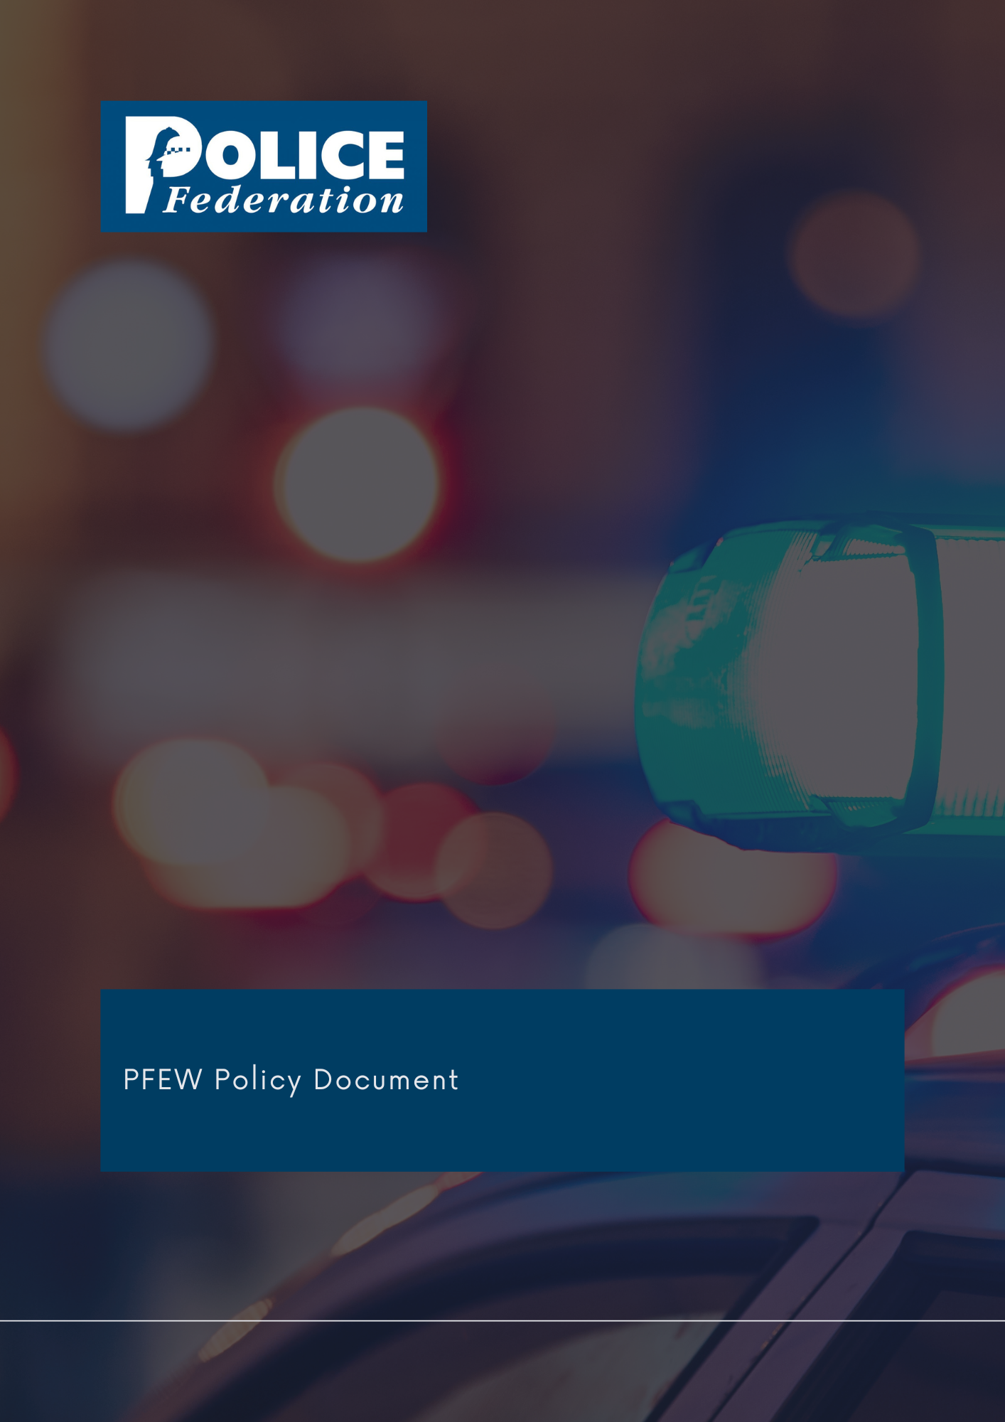
Firearms Policy

Version 1
2024

The PFEW Policy Department has embarked on a programme to formulate and revise policy documents on matters of particular importance to its members.

It is the aim of PFEW to maintain clear policies on key topics that allow members to understand PFEW's official position on those areas.

These strategic documents are evidence-based, aligned with PFEW's Business Areas and championed by National Board members.

If you have any comments or queries, please direct them to Bahar.Munim@polfed.org

Approved by National Board: June 2024

FIREARMS
1. Policy statement

Firearms units and those officers that undertake such duties play an invaluable role in protecting and reassuring the public from immediate threat to life situations.
As the figures for gun and knife crime continue to increase in the UK, the Police Federation of England and Wales (PFEW) continues to encourage police officers to be trained specifically as Authorised Firearms Officers (AFOs) to ensure a capability to respond to incidents that are deemed serious enough to warrant a firearms response are maintained.
Those officers that volunteer for such a role should be secure in the knowledge that all has been done to protect their safety. This means having the appropriate provisions put in place e.g. the highest quality training, reliable and sufficient equipment to deal with varied incidents they will be called to deal with, and related ongoing support and development to maintain their skillset.
Following any incident involving the use of a police firearm, that incident must be scrutinised, and lessons learned. However, this must be balanced with the support that the officers involved in the incident require. This includes the way officers are treated by any Post Incident Management procedure and subsequent ongoing processes.

2. Responsibility

The PFEW National Board is responsible for all policy formation.

3. Summary
PFEW believes that police officers should not be routinely armed on duty. Officers who choose to carry a firearm are volunteers.
PFEW believes that the number of Authorised Firearms Officers (AFOs) should be reviewed regularly to ensure there are sufficient numbers when set against national and local firearms strategic threat and risk assessments. Officers who have the difficult job of protecting our communities, and choose to carry a firearm, must have confidence in processes put in place. The current Authorised Professional Practice Armed Policing policy (APP), adopted by the Service, including the Independent Office for Police Conduct (IOPC), gets that balance right - it supports an effective investigation and ensures the integrity of the process whilst protecting individual officers who are vulnerable to negative complaints. Post-Incident Procedures (PIP), under the Firearms APP is a recognised practice used by all forces in England and Wales. The APP should be adhered to, except when legal advice suggests otherwise. Conferring during a post incident is not a sinister practice. It is aimed at capturing the best evidence possible following extremely stressful and life-threatening situations.

4. Procedures/implementation
PFEW will continue to engage with the NPCC, the Home Office and IOPC to review PIPs to ensure that they facilitate the investigation, ensures the integrity of the process and address the needs of the officers, at a time when they are potentially vulnerable. PFEW will represent the interests of firearms officers and other officers involved in death or serious injury investigations - both at the investigation stage and at the inquest stage. PFEW provides training for Federation representatives to familiarise them with PIP where there has been death or serious injury involving police contact.

