Dear Member,

I do hope your application to be admitted to the Police Rehabilitation Centre (Flint House) at Goring-on Thames will be accepted since I am quite sure that you would find the experience both enjoyable and beneficial.

If you are also a subscriber to the Force Benevolent Fund there is a provision in the fund rules which allows us to make a contribution towards your travelling costs. From 1st January 2016 the Fund will reimburse you for one journey to and from Flint House, at the rate of 45p per mile if you drive to the venue, or we will cover the cost of one second class return fare if you choose to travel by train.

There is a specific form to be completed in respect of all Flint House travel claims which can simply be downloaded from our webpage www.kpbf.org.uk. Once complete, please return the form to me as soon as possible after your treatment at Flint House has ended. To expedite the payment we ask that you email the completed form directly to us at the email address at the bottom of this form.

If you have any further questions regarding your expense claims feel free to contact me. Please be aware that we are now home based workers so email or the below mobile number during office hours is the easiest way to contact me. or Debbie O’Neill at the Benevolent Fund Office.

Yours sincerely
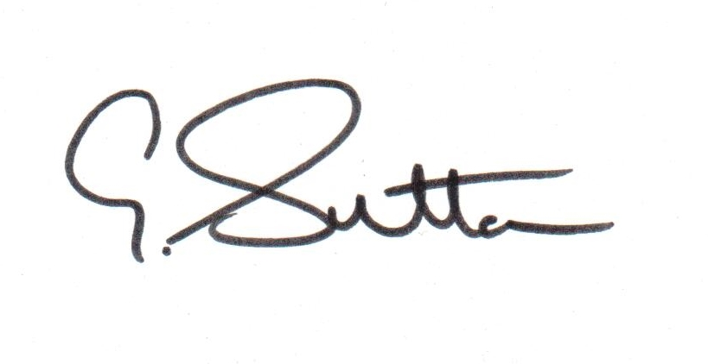
Gary Sutton.
Benevolent Fund Secretary

.

