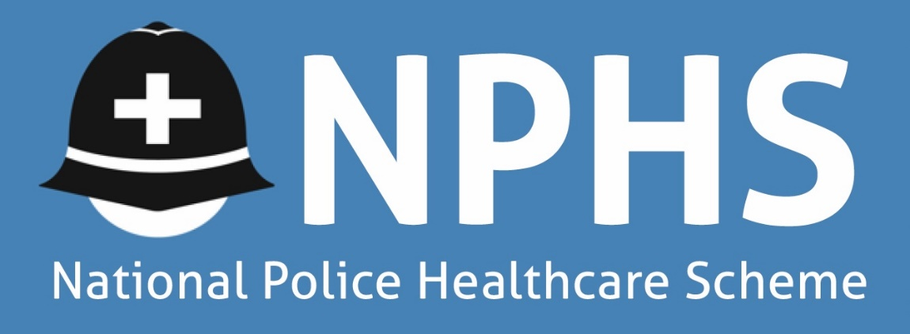
11-14 Apex Business Park, Annitsford, Cramlington, Northumberland NE23 7BF
Tel: 0191 4373000 Email: healthcare@npf.org. Website: www.norpolfed.org
VAT Reg No. 993179764

Date as Postmark

Dear Colleague

THE NATIONAL POLICE HEALTHCARE SCHEME

FREE MEMBERSHIP FOR FIRST 12 MONTHS OF PROBATION (OFFICER ONLY)

We would like to inform you of an excellent opportunity to join The National Police Healthcare Scheme.
Once you subscribe to the Police Federation, you will be eligible to join the scheme on completion of the membership form (attached). During the first 12 months of your probation, membership for you is FREE. If you wish to add your spouse/partner or any dependent children, please see rates below, which are applicable from the date of you joining the Scheme.

THIS TABLE REFERS TO FIRST YEAR MEMBERSHIP ONLY
Members Age | 18-29 | 30-39 | 40-44 | 45-49
Member Only | Free for 1st Year | Free for 1st Year | Free for 1st Year | Free for 1st Year
Member & Spouse | £ 16.00 | £ 22.00 | £ 27.00 | £ 33.00
Family | £ 30.00 | £ 36.00 | £ 41.00 | £ 47.00
Member & Child(ren) | £ 14.00 | £ 14.00 | £ 14.00 | £ 14.00

THIS TABLE REFERS TO MEMBERSHIP AFTER THE FIRST YEAR

Members Age | 18-29 | 30-39 | 40-44 | 45-49 | 50-54 | 55-64 | 65-69 | 70-74 | 75-79 | 80+
Member Only | £16.00 | £22.00 | £27.00 | £33.00 | £37.00 | £ 46.00 | £ 58.00 | £100.00 | £120.00 | £140.00
Member & Spouse | £32.00 | £44.00 | £54.00 | £66.00 | £74.00 | £ 92.00 | £116.00 | £200.00 | £240.00 | £280.00
Family | £46.00 | £58.00 | £68.00 | £80.00 | £88.00 | £112.00 | £144.00 | £230.00 | £270.00 | £310.00
Member & Child(ren) | £30.00 | £36.00 | £41.00 | £47.00 | £51.00 | £ 66.00 | £ 86.00 | £130.00 | £150.00 | £170.00

The main benefits of the Scheme are as follows:-
- Payment of all private expenses designed to cure or alleviate acute medical conditions or ailments;

- Covers specialist/consultation fees, tests & scans, hospital accommodation, surgeon & anaesthetist costs, physiotherapy, osteopathy, acupuncture, and chiropractic treatment;

- Payment of a cash benefit of £100.00 per day for day-case surgery as an NHS outpatient or per night as an in-patient of the National Health Service in respect of any treatment received by them free of charge (except emergency admissions). The maximum amount claimable is £2,500 in any twelve-month period. Claim forms must be returned within 14 days of discharge.

Please note that the full membership rate, as shown on the above table, will be payable from the start of your second year. There is no obligation to remain in the scheme following your free membership period.
If you wish to remain in the Healthcare Scheme after your first year of service, you will automatically receive FREE Police Treatment Centre membership, as this is incorporated within the Scheme.
Please take the time to discuss the benefits of the scheme with your family. If you feel that you would like to take advantage of this excellent opportunity, please complete the enclosed application form, and return it to the Federation Office as soon as possible.
If you wish to discuss any aspects of The National Police Healthcare Scheme, please do not hesitate to contact The Healthcare Administrators, on 0191 4373000 or email Healthcare@npf.polfed.org
Yours sincerely

Branch Council Chair

On behalf of the Trustees of
The National Police Healthcare Scheme

