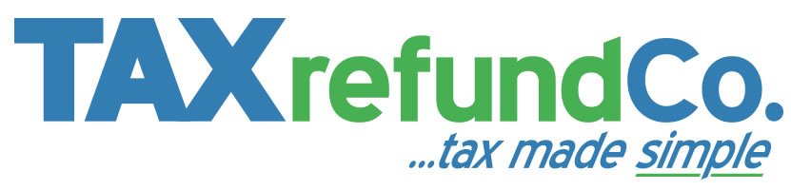

Dear Federation Member

IMPORTANT: You could be owed a tax refund

In these worrying times, paying too much tax is probably the last thing on your mind!

Right now you`re probably doing everything you can to help minimise the number of people struck down by this awful pandemic, but at the same time, it’s important not to ignore your own financial well-being. Your employer has just started using your new 2020/21 tax code and given the evidence we’ve seen, there’s every chance it’s wrong and you`re paying too much tax.

So when you get the time, don’t forget to check yours. While you’re at it, it’s also worth checking the codes you were given for the last 4 years as well. If you find anything wrong, get in touch with HMRC and you might get your money back.

If you haven’t got the time, or just don’t understand tax, please remember we`re here to help you, just as we’ve helped more than 48,000 of your colleagues across the UK.

We promise, in fact we guarantee, we’ll get back everything HMRC has wrongly taken off your pay for this year, and the past 4 years. We’ll even pay your tax bill if you get sent an unexpected tax bill as a direct result of our work!*
Before you ask us to help you, please take a moment to read these 4 key points:

- If we can’t get you a tax refund, there’s nothing to pay. The service will be free of charge
- For every £1 we do get back, you keep 62p (minimum fee £38*)
- You keep 100% of any money we save you in this 2020/21 tax year

To get your tax checked and see if you’re due a tax refund for this year, or previous years, click here

This is your hard earned money. Why let The Revenue keep it?

*If your refund is less than £38, the minimum fee will be reduced to the same value as your refund so you have nothing more to pay

Any Questions?
Call The Tax Refund Company on 0161 968 7345 (Mon–Fri 9am – 5pm) or see our Frequently Asked Questions at www.thetaxrefundcompany.co.uk/faqs

