Police Federation Wellbeing Webinar | Breaking the Silence – Conversations

about Mental Health and Suicide Prevention

Register now for upcoming event!

In support of International Suicide Prevention Day on September 10th, 2024, this webinar is dedicated to our #AskTwice campaign, which aims to foster open conversations about mental health and provide support within policing and the community.

During the session, we will hear from a representative who will share his personal struggles with mental health and discuss his role as Branch Secretary and Wellbeing Lead, where he has supported numerous members over the years, particularly through ill health retirement.

Additionally, Dr Jess Miller will explore the types of thinking that can lead to suicidal thoughts and will educate and encourage teams to cultivate an environment that counteracts and addresses these harmful thought patterns.

This event is free to attend for all police officers and police staff.

Click on the image below to view the agenda and register.

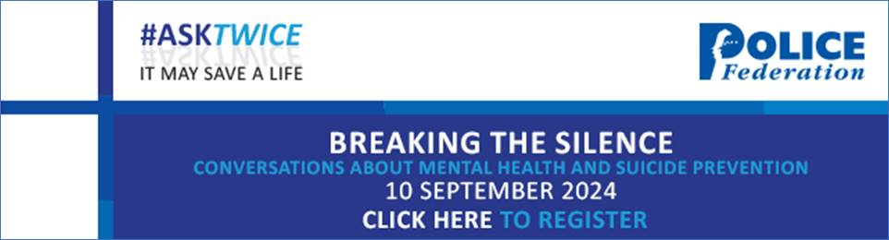

Kind regards / Cofion cynnes

PFEW Events Team
Tîm Digwyddiadau PFEW

Police Federation of England and Wales
Ffederasiwn Heddlu Cymru a Lloegr
​​​

