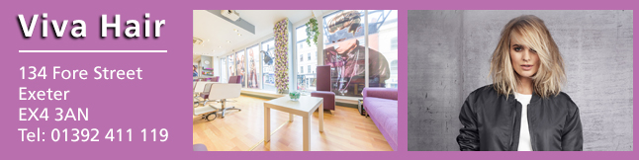  
**Exclusive Invitation for Devon and Cornwall Police Federation Staff Members - 75% OFF**

The team of professional stylists at **Viva Hair**would like to welcome you with this Exclusive Pamper Experience. You are being invited to come and indulge yourself over **3 separate visits** to the salon and sample a range of services that the salon brings to the high street near you.

**VISIT 1 - CUT & BLOW DRY**

Personal Style & Colour Consultation

Shampoo & Conditioning  
*inc. Mini Scalp Massage*

Cut & Blow Dry  
Complimentary Beverage

**VISIT 2 - HI/LOW LIGHTS & BLOW DRY**

Colour Consultation

Shampoo & Conditioning *Inc. Mini Scalp Massage*

Half Head Highlights  
Complimentary Beverage

**OR**

Half Head Balayage

Blow Dry  
Complimentary Beverage

**VISIT 3 - WASH & BLOW DRY**

Follow up Style & Colour Consultation

Shampoo & Conditioning  
*inc. Mini Scalp Massage*

Blow Dry  
Complimentary Beverage

Following on from these 3 Visits, you will be entitled to a Corporate Loyalty Scheme giving you 10% OFF

*Additionally, with each visit you can make the most of our* optional **UPGRADE TREATS***section which includes additional great value treatments that can be added to your visits above such as Full Head Highlights, Full Head Balayage & other colour services.*

This extensive package is ***normally valued over £200*.** This **ENTIRE** exclusive pamper experience can be purchased for just

**£39.95!!**

This promotion is valid to **new clients only who have not previously visited Viva Hair Exeter within the last 12 months**Those valued existing clients are welcome to purchase these certificates as gifts for friends & family members instead

***Why not take advantage of the below offer:***

**1 x Voucher - £39.95**

**2 x Vouchers - £74.00 (saving £5)**

**3 x Vouchers - £109.00 (saving £10)   
4 x Vouchers - £144.00 (saving £15)**

**How to purchase an Exclusive Pamper Experience or to enquire further:**

Give our Marketing representatives at Salon Select Londona call on the numbers below. Payment can be taken over the phone and all certificates will be sent directly to you. She will be happy to answer any questions you may have

Office Line:**01992 248 040**(Office: 9am-5pm Monday to Friday)

or Mobile: **07568 389 572**(Office hours, Evenings & Weekends)

**Email:**[**elena@salonselectlondon.co.uk**](mailto:elena@salonselectlondon.co.uk)

***We only have a limited number of Exclusive Pamper Experiences available so don't miss out!***