Office Use Only: Applicant ID:

Application to stay at the Finlake Holiday Lodge
Please include your/ the officers personal details including personal email address, contact number and home address. If your application is successful, our booking system requires personal contact information, as we will not be able to send the necessary information via Force email. Any application not containing personal details will be returned to the applicant for resubmission

Full Name
Collar Number
Home Address
Home Telephone Number
Mobile Telephone Number
Home Email Address
Job Role
Base Station
Group Insurance Member for more than 3 months

I have read, understand and accept the Privacy Policy Fairways (End of document) x

I DO WISH to be contacted by Devon & Cornwall Police Federation and
Finlake Fairways in relation to news and special offers in future x

I AGREE to the general Terms and Conditions of stay at 11 Finlake Fairways x

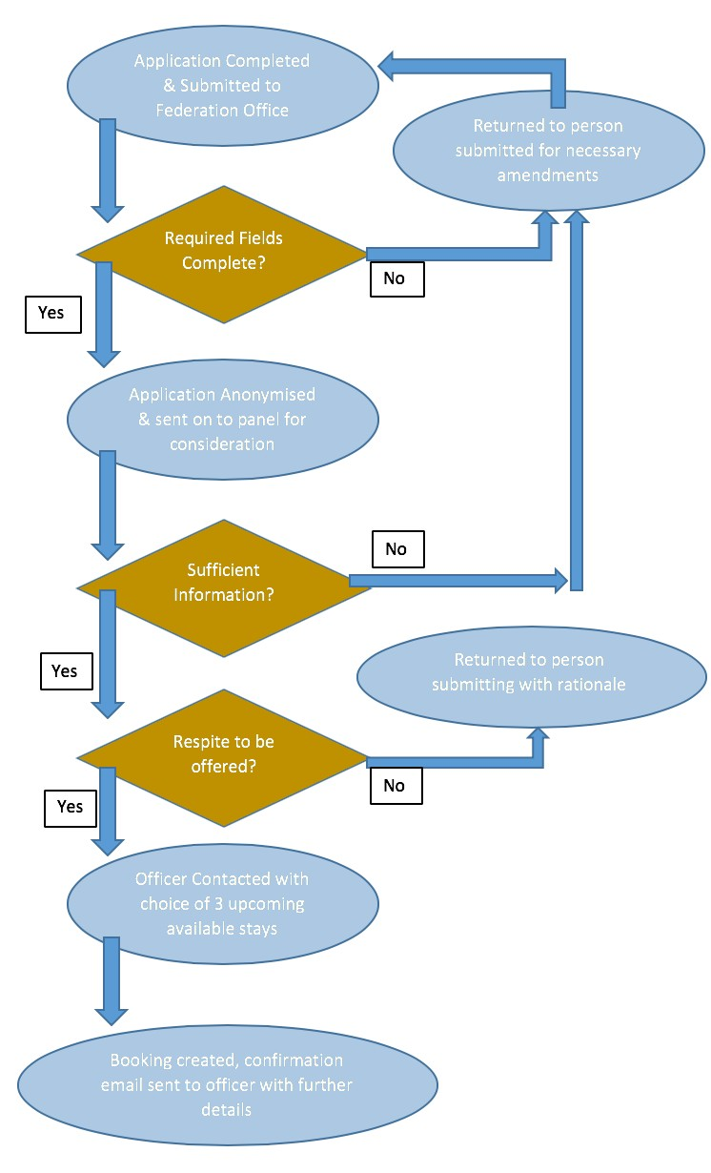
The Application Process:
1

Version Date: October 2019

Have you/ the officer had a respite stay at Finlake before? Y/N

If yes, please give date(s) and whether the circumstances relating to this application are different/the same as previous applications
Are you/the officer currently suspended? Y/N

If yes please provide details.
Are you/the officer currently off work? Y/N

If yes please provide details:
Why do you think a stay at the lodge would benefit you / nominee?
Please provide any further details you believe would assist the panel in making a decision as to whether you are given a respite stay.

How many nights would you wish to stay for? 3 - Weekend (Fri/Sat/Sun)
4 - Weekday (Mon/Tues/Weds/Thurs) or 7 - Mon – Mon or Fri – Fri

The decision on the number of nights allocated will be made by the panel on the information provided by the applicant and any other information known to them. The offer of a stay at the holiday let is subject to the officer agreeing to the usual terms and conditions.

3

Name of person submitting (if not officer subject of application.)

Please note, the subject officer will need to read and understand the privacy policy and terms and conditions of stay and indicate this on page 1 of the document
BCU / department comments and in particular whether the application is supported.
Federation Rep comments.

If submission not from within Federation, then Fed Rep comments will be required.

Comments from work base or Main Time BCU Rep both acceptable.

Main Time BCU Reps are:

Plymouth: Andy Collins Cornwall IOS: Mark Atkins South Devon: Nick Jones NEW Devon: Suzie Vranch

Version Date: October 2019
3

Comments by panel.
Stay authorised Y/N.

Privacy Policy

We take the privacy of our guests very seriously. We ask that you read this Privacy Policy ('the Policy') carefully as it contains important information about how we will use your personal data.
For the purposes of the Data Protection Act 1998, Devon and Cornwall Police Federation trading as ‘Finlake Fairways’ ('we' or 'us') is the 'data controller' (i.e. the company who is responsible for, and controls the processing of, your personal data).
Personal data we may collect about you:
We will obtain personal data about you (such as your name, address, telephone number, email address) whenever you complete a form.
For example, we will obtain your personal data when you submit a respite application. We may also obtain sensitive personal data about you if you volunteer it during the completion of a booking form.
If you provide such information, you will be consenting to our processing it for the purpose of providing accommodation services to you.
How we may use your personal data:
We will use your personal data for the purposes of providing services to you as a customer or potential customer of Finlake Fairways These purposes include:
- to help us identify you and any bookings you hold with us
- administration
- statistical analysis
- fraud prevention and detection
- customising this website and its content to your particular preferences
- to notify you any changes to this website or our services which may make
- improving our services
If we are under a duty to disclose or share your personal data in order to comply with any legal obligation, or in order to enforce or apply our terms and conditions and other agreements; or to protect the rights, property, or safety of Finlake Faiways, our partners, or others. This includes exchanging information with other companies and organisations for the purposes of fraud protection.
We may disclose your personal information to our third parties limited to HomeAway, Air BnB, Haulfryn Group for the purposes of securing your booking at 11 Finlake Fairways. We may also disclose your name and dates of stay to assist housekeeping and maintenance.
Keeping your data secure:
We will use technical and organisational measures to safeguard your personal data, for example, we store your personal data on secure servers and in lockable cabinets with authorised access only.
Your rights:
You have the right to request access to personal data which we may process about you. If you wish to exercise this right you should:
- put your request in writing
- include proof of your identity and address (eg a copy of your driving licence or passport, and a recent utility or credit card bill)
- specify the personal data you want access to, including any account or reference numbers where applicable. You have the right to require us to correct any inaccuracies in your data free of charge. If you wish to exercise
this right you should:
- put your request in writing
- provide us with enough information to identify you
- specify the information that is incorrect and what it should be replaced with.
Our contact details:
If you wish to contact us:
- please send an email to finlakefairways@gmail.com
- write to us at 2 River Court, Pynes Hill, Exeter, EX25JL.
- call us on 01392 354770

Terms & Conditions of Respite Stays
4
By your acceptance of confirmation by communication from Finlake Fairways our holiday letting policy will now be active, and adhered to by both guest and owner.
It is agreed that the owners will let and that the guest will take, the furnished premises at 11 Finlake Fairways, Finlake Leisure Resort, Chudleigh Devon, TQ13 (the premise) for the time period requested by the guest and agreed to by the owner.
For Respite stays, the owner agrees to waive the £75 refundable security deposit. However, as any granted to you is granted to you in your capacity as a Police Officer, the guest agrees to inform the owner of any breakages or damage within 24 hours of occurrence. Substantial damage may result in a charge for repair or replacement.
The Guest agrees with the Owner as follows:
- Not to deface, make any alterations or additions to the interior or exterior of the Premises or to the decoration, fixtures or fittings of the Premises or to the furniture. Please note the inventory list and reported damage form is attached. We reserve the right to deduct any breakages, damage or loss from the security deposit.
- To keep the furniture, soft furnishings and equipment in their present state of repair and condition and to replace with similar articles, of at least the equivalent value and standard, any items of furniture which may be found to be missing or destroyed (reasonable wear and tear excepted).
- Not to remove any of the furniture from its present position in the Premises.
- To use the premises as a private holiday residence for up to 6 persons only and not for any other purposes whatsoever. Additional persons may be accommodated by prior arrangement only.
- Not to affix any poster or placard to the interior or exterior of the Premises.
- Not to do or permit to be done anything which may be a nuisance or annoyance or cause of damage to any neighbouring or adjoining property.
- Not to do anything or permit anything to be done as a result of which any policy or insurance held by the Owners on the Premises may become void or voidable or subject to an increased rate of premium.
- Not to use the property for any illegal or immoral purposes.
- To permit the Owners or their agents access to the Premises to deal with any maintenance or security issues.
- Not to smoke or permit smoking inside or on the Premises.
- Not to allow pets inside or on the Premises. (Unless accompanied by a registered assistance dog- in this instance we will need to further contact to ensure needs are met)
- To accept and abide by the General Terms & Conditions that comprise Page 2 of this Holiday Letting Agreement.
On completion of the letting period: The Guest agrees to leave the Premises and the furniture, in a clean and tidy state of repair and condition and in accordance with the provisions of this Agreement.
Finlake Fairways shall not be liable for death or any personal injury. No liability is accepted for any other damage, injury, loss, expense accidental or otherwise or inconvenience to you or any member of your party and/or your or their belongings, damage by or to any third party or for damage to any motor vehicle or its contents which may be suffered, incurred, arise out of or in any way connected with the let.

Version Date: October 2019

