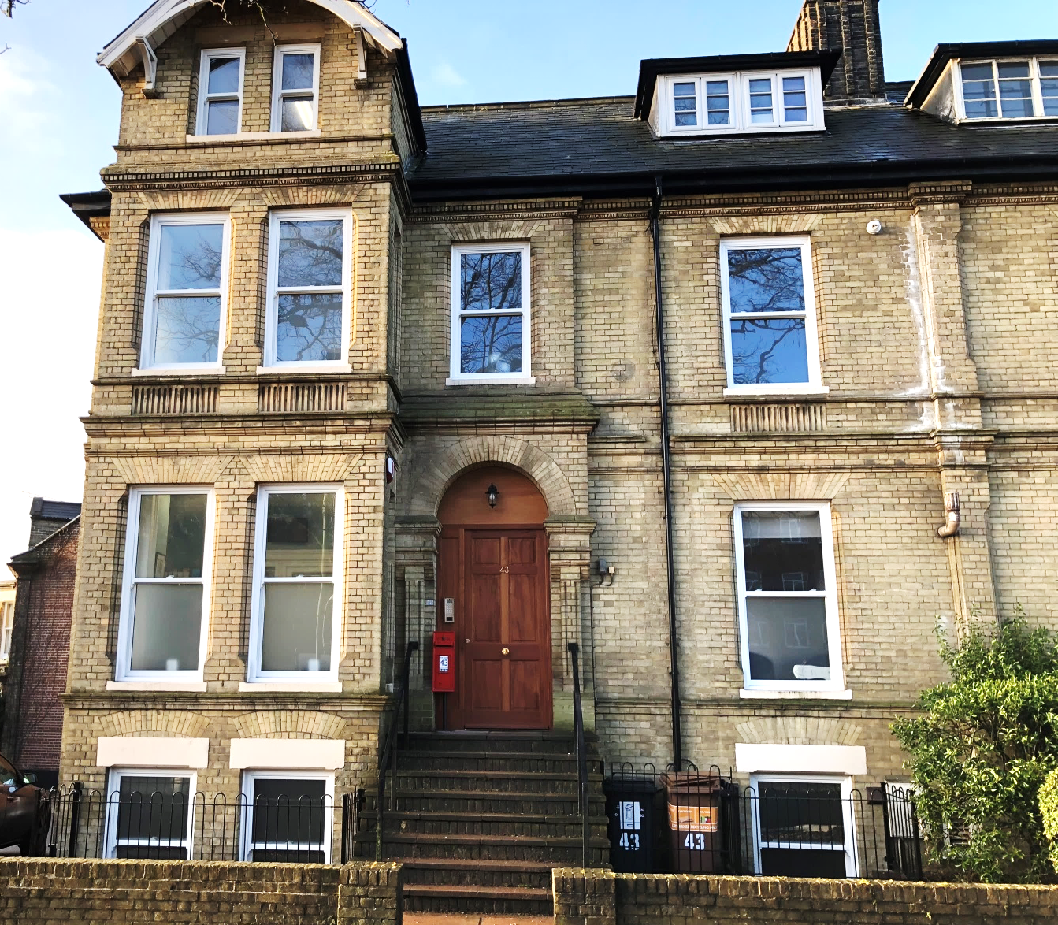

Picture – new offices at Norwich, which opened its doors to members on 11th December 2017
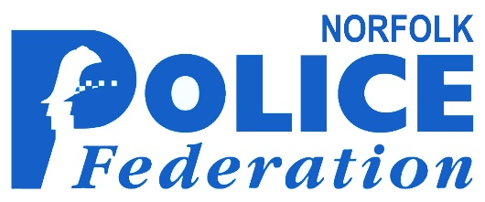
Annual Report

2 0 1 7


The Federation’s
core purpose

The core purpose of the Police Federation of England and Wales (PFEW) is:
That PFEW agrees that, in fulfilling its statutory responsibilities for the welfare and efficiency of its members, the Federation at all levels will:
l Ensure that its members are fully informed and that there is the highest degree of transparency in decision-making and use of resources.
l Maintain exemplary standards of conduct, integrity and professionalism.
l Act in the interests of the members and the public, seeking to build public confidence in the police service and accepting public accountability for its use of public money.
l Work together within the Federation and in partnership with others in the policing world to achieve its goals.

Norfolk Police Federation branch first six-month strategy for 2017:
l To represent Norfolk officers, to alert the public and influence local councils, partners and appointed Norfolk MPs, of the effects that any further budget cuts in the life-time of the next Parliament would have in line with the PFEW national strategy.
l To highlight the changes to crime patterns, the myriad of other non-crime related incidents and the working practices impacting on the workload and welfare of officers.
l To raise the issue of those officers who are suffering acute and chronic mental ill-health, especially due to work-related issues.
l To continue to shape Norfolk Police Federation branch in line with Sir David Normington’s independent review and consistent with the timelines laid down by PFEW and the Home Office.
l To identify and promote officer safety issues during times of reduced workforces, increased workloads and changes in legislation.
l Share and support any national campaign to highlight the role of policing in society (namely Protect The Protectors).

2

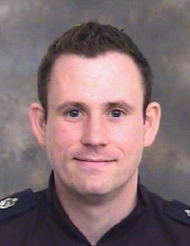

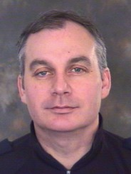
Introduction
from the
branch secretary

Keith Bristo

This year’s 2017 annual report is a brief insight into the work that the Federation representatives undertake, including changes to the structure and location of the branch.
More and more officers are requiring Federation assistance and the peaks and troughs in demand are now gone which has left a very steady and rising demand. This increase in the demand on the Norfolk Police Federation (NPF) has led to this members association taking on new premises, which will accommodate our workload, and the people involved. These new office facilities have many amenities all designed to make that moment when your needs are at their highest, accommodate those needs quickly and privately. We do not need to book rooms on police premises; we do not need you to come to police premises any longer to speak with your welfare team.
I hope that 2018 sees you safe and well and doing the vocation you have opted to do and are dedicated in doing, when you are struggling remember your federation are here to help you.
View from the
branch chair

Andy Symonds
It has been a year since I took over the role as your Chairman, having been elected in January 2017.
I
I joined the Federation back in 2012 when I was based at Great Yarmouth, I enjoyed spending my time helping and supporting colleagues as a local workplaces rep. As your Chairman I am the voice of all 1500 federated police officers in Norfolk. This role is demanding but I have a passion to help people that require support for various reasons at different points during their career.
I am acutely aware of stresses and strains placed upon you all with the increase in calls for service and the demand created from other public sectors that have reduced their service to the public. Mental health related calls have increased and the strain that is placed on the police and cannot be underestimated, many of these calls should never be directed to the police.
The ambulance service has buckled under their own demand meaning that the police service has been left as the service of last resort to pick up the pieces.
Many if not all of you are carrying large amounts of crimes which you are expected to investigate fully in between all of the CAD’s.
Please do not try to juggle all of this on your shoulders, speak with your supervisor and tell them!

Feed into national PFEW structure
Branch chairman
Andy Symonds
Norfolk Federation Branch Board
Responsible for leading and running operations and services and the decision-making body consisting of nine elected council members of mixed ranks
Branch secretary
Keith Bristo (Treasurer)
Norfolk Federation Branch Council
Currently nine constables, six sergeants, four inspector ranks, and two reserve reps
Structure of the Norfolk Police Federation branch
Federation office Officer managers ( job share): Matt Gould and Helen Wickens Case manager: Paul Ridgway Office support: Sheryl Irving
Federation representatives

Pay and morale survey
PFEW ran a national pay and morale survey during 2017 to help inform the Pay Review Body. Here are highlights of the local Norfolk results:
Norfolk officers gave 497 responses (which is slightly up on 2016 with 494 responses), representing a response rate of around 33%. The national response rate for the 2017 survey was 25% (down from 35% in 2016).
71.9% of respondents were Constables, 21.1% were Sergeants and 7.0% were Inspectors or Chief Inspectors.

Morale
The 2017 survey of Norfolk Constabulary rank and file officers found that 64.3% felt that their own morale was low.
l 64.3% said the factor negatively affecting officers’ morale is a lack of work-life balance.
l 89.5% said that it is the way police are treated as a whole.
Pay
l 67.4% felt they are worst off financially compared to five years ago.
l 87.2% said they are not paid fairly given the stresses and strains of the job.

Conduct and performance

The Conduct and Performance lead Officer (CAPLO) is Andy Symonds and the deputy is Nick Cheshire.
In many cases, the misconduct proceedings can be the result of a spurious claim, an honest mistake or a moment of inattentiveness to the rules. Under-performance can often be because of an underlying issue that needs to be addressed. In these cases, specially trained conduct trained representatives can advise members, making representations on their behalf to the appropriate authority and negotiate outcomes.

Supported and represented at misconduct meeting
8
Vulnerability interview (potential unsafe contact with third party)
15

Supported and represented at special case hearing (fast-track)

Supported and represented at misconduct hearing
3
Gross incompetence hearing
0

0

On duty conduct
75

Formal unsatisfactory Performance Procedures (UPP)
5

Off duty conduct
25

Student officer supported during regulation 13 performance procedures
5

Informal performance procedures
32

Public complaint, no misconduct
14

Other general legal advice Issues
192

Post-Incident Procedures

Post-Incident Procedures (PIP) are investigations into the death or serious injury of an individual following police contact or intervention. These procedures, outlined by the College of Policing Authorised Professional Practice (APP), were designed for firearms deployments but are adapted to deal with incidents in custody, collisions involving a police vehicle or any use of force.
There are set procedures to be followed to ensure the integrity of the investigation while considering the welfare of the officers involved.
Some involve a local investigation while others are undertaken by the Independent Police Complaints Commission (IPCC).
The procedures are more complex than can be explained here but we have volunteer specialist trained Federation representatives available to assist members through the process to ensure they can give best evidence.

Number of members assisted
49

Chairman’s message

By Andy Symonds

Your Chair, Andy Symonds has been busy organising a PIP Seminar/CPD Event which is the first of its kind held in Norfolk. The event was held in the Gym at OCC which was the only venue big enough to hold around 100 people. The event took place on 16th March 2018 and was well attended. We had a number of expert presenters including the PFOA (Police Firearms Association) who gave an input on the WSP (Welfare Support Programme). An excellent presentation from C/Supt Chris Mead and C/Inspector Julia Hands who were the PIM’s for the fatal shooting that took place in Cambs. The Norfolk and Suffolk PIM’s took on the first class learning at the event. We also heard from one of the KPW from that shooting who shared his experiences of going through a PIP after a traumatic and serious incident.
We were also lucky to secure the time of Scott Ingram from Slater & Gordon; he is the lead for PIP’s at Slater & Gordon. Mr Ingram gave a presentation that covered the issues around BVW and PIP, separation as well as the current issues around the IOPC and officers being either witnesses or subjects of the investigation.

The event was arranged for a few reasons and the most important of these reasons was to raise awareness of PIP to officers. It is also important that we glean as much learning from these sorts of events so that when we have a PIP in force all those involved in this process has the right training and expertise to make the PIP as slick and efficient for those officers taking part. The impact on officer’s wellbeing cannot be underestimated when they are involved in these sorts of incidents which lead to a PIP.
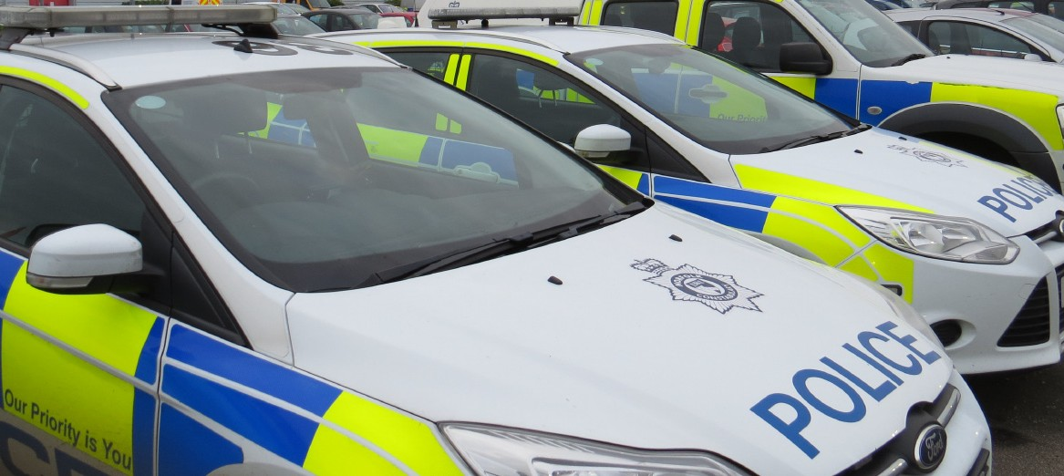
6

Officer workload
By Andy Symonds, Federation chairman

In the detective world the increases in reports of abuse have rocketed and at the same time so to have historic reports of abuse. This is a perfect storm, which has meant the workloads carried by detectives have hugely increased. They carry a huge weight of responsibility on their shoulders and require the support of the force to be able to cope without falling ill themselves. This is in my view why we have a national crisis in the recruitment of detectives. You will all be aware that Suffolk currently has an intake of students that are training as detectives who will not be doing the traditional 2 years in uniform. The Met have a similar programme, I recently spoke with an IOPC (Independent Office Police Conduct) investigator who is joining the MET on their detective programme.
You will all be aware now that the force has been recruiting quite a lot and some of you have come across the students who had just 10 weeks initial training. We disagreed with the reductions from 18 weeks down to 10 weeks and we made our views very well known to the Chief Constable. However, the force decided that they required police officers out of training far quicker to help bolster the numbers. Please help and support these colleagues, they have been through a tough 10 weeks. Please feedback any concerns you have to your local Fed rep or the Fed office. We need to hear your concerns so that we can raise them directly with the force.

CICA and civil claims
Criminal Injuries Compensation Authority (CICA) claims The Government introduced a new version of the CICA scheme on 27 November 2012. This means that certain injuries are no longer classed as being serious enough to warrant a claim through the CICA. Examples of physical injuries no longer in the scheme include bruising, black eyes, minor scarring, broken nose, broken/ loose teeth and broken ribs. Other injuries like fractured fingers, a broken hand, ligament damage, dislocation and the like are still eligible for an award only if it can be shown that there is a ‘continuing significant disability’. For psychological injuries, there must a psychiatric diagnosis.
For officers with serious injuries this could severely affect their future career and life.

CICA 2017summary 5 new claims 7 claim finalised
4 claims ongoing.

Civil claims 2017
Civil claims can prove controversial for police officers if pursued as a result of their duty. However, the majority relate to incidents not connected with work matters. The Federation helps those wanting to make a civil claim by referring the case to a legal advisor for assessment. Claims are settled via the respective legal advisors.

12 claims opened 2 claims finalised. 2 claims with awards (total compensation of £18,602.49)
1 - No award
19 – Claims outstanding, Includes medical negligence, claims for employer liabilities and road traffic collisions.

Equality and workplace issues

The Equality Lead Officer (ELO) is Sam Hawkins.
Federation representatives have many conversations with members about perceived unfair treatment at work. Many just result in no more than a confidential conversation and advice. Some go on to informal action; others to the more formal Fairness at Work (FAW) procedures; some can be considered for an employment Tribunal. All these procedures are not about apportioning blame but about finding a resolution at the earliest stage. The Federation also works alongside other support networks.
The below gives a general idea of the
number of members we assist. We do not record quick verbal advice or where no further action is taken. These are all cases where a Federation representative has had to take some action or negotiate with the Constabulary to pursue a resolution.
Early resolution helps keep a member at work and keeps the officer focused on their demanding job rather than worrying about workplace issues.
Not all issues are easy to resolve or indeed can be resolved; but the Federation helps to find resolutions where possible while trying to ensure that the member is treated fairly and lawfully.

Stage 1 Fairness at Work or bullying procedures
18
Informal Fairness at Work or bullying procedures
39

Career break assistance
15

Business interests applications
8
Assistance with maternity related issues
18
Employment Tribunal registration 12
ACAS registration of workplace issue
5
Stage 2 Fairness at Work or bullying procedures
9

Whistleblowing
9

Other general issues
221

Salary over-payment
22
Assistance with flexible working or part-time requests
39

Sickness, UAP, limited duties, ill-health
and welfare support

All Federation representatives receive Attendance Support training and can assist with advice and representation at Attendance Support Meetings (ASM) or in relation to sickness matters. More specialist advice and support is available for the unsatisfactory Attendance Procedures (UAP), ill-health retirements, Police Injury Benefit regulations, half pay issues and Adjusted Duties Meetings (ADM).
Issues 2016

Cases during;
2017
The Federation supports officers through advice, referrals and options for the future. Sometimes this can help in getting an officer back to work quicker or, if needed, secure a dignified exit from the service. It is important that officers are treated fairly when it comes to health matters particularly any injury or mental health issue obtained as a result of putting themselves in harm’s way to protect the public.

Officers supported at Attendance Support Meetings  (could be just one meeting or a series) |  | 82
Officers supported through reduced pay appeals due to long-term sickness (could be one or several appeals on each case) |  | 27
Officers supported through the ill-health retirement process (this can take several months) |  | 15
Appeals to the Police Medical Appeals Board (PMAB) about ill-health retirement |  | 2
Officers supported through the injury award process after ill-health retirement due to work-related injury |  | 3
Officers supported through unsatisfactory Attendance Procedures (UAP) |  | 5

Expenditure on medical reports to assist members through the above processes: £0
The Police (Amendment) Regulations 2015 mean an officer can be placed on adjusted duties if they are not fully deployable because of a medical reason for an extended period. Relevant officers are being called to Adjusted Duties Meetings (ADM).
Unless certain conditions apply, it could lead to a reduction in salary after one year of adjusted duties. Federation representatives trained in equality are available to assist members through the process and try to prevent potential discrimination in applying the policy. This has caused a lot of angst and stress among those affected and an increased workload for the Federation. Officers attend regular review meetings.
Officers assisted at Adjusted Duty Meetings during 2017: Equality – within General Issue’s numbers

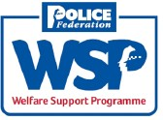
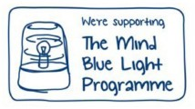
Welfare Support Programme Norfolk Police Federation is linked in to the Mind Blue light Programme and the PFEW and Police Firearms Officers’ Association (PFOA) Welfare Support Programme (WSP) in order to support officers and their families in difficult situations or suffering mental health issues.

Insurance schemes

Group Life Insurance Scheme including RAC cover*

Group cover provided along with the option for spouse cover plus RAC cover*:

Legal expenses protection insurance (LEPI)

This is a comprehensive legal protection insurance at greatly reduced cost and covers most legal issues for members and their families. It covers off duty matters. A court defence for a non-work related matter will not be funded by the Federation and can run into tens of thousands of pounds. A police officer is unlikely to get legal aid.

Travel insurance
These inclusive policies cover the family.
Terms and conditions apply.

Sickness insurance
To cover for half pay situations during long- term injury or illness (after six months)

* For its members, Norfolk Police Federation offers a comprehensive top of the range, breakdown and recovery service provided by the RAC which includes European travel and embraces a wide variety of vehicles including motorcycles and camper vans. This cover is combined with the Group life Insurance Policy thereby providing excellent value for money.

MEMBERS ONLY
For further information, policies or application forms on any of the above, please see the website www.polfed.org/norfolk

Meetings and events
Federation representatives have a major role to play in attending meetings and events to influence and negotiate on all matters to do with the welfare and efficiency of members. For instance, there are national Federation meetings like the Interim national Council (a meeting of all the Branch chairs and secretaries with the national representatives) or specialist national meeting in areas like conduct or equality to ensure representatives are continuously professionally developed and

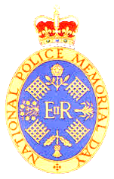
can give the best advice.
There are local meetings with various departments in the Constabulary including the Joint negotiating and Consultative Committee (JnCC), working groups, meetings with heads of departments and consultations on Force policy. We represent our members at national events like the national Police Memorial Day as well as meeting with the Police and Crime Commissioner and local MPs.

Health and safety: an overview

The dedicated health and safety lead is Shane Schucroft. Shane has been working on various projects with the Force throughout the year. This vital work helps ensure the safety of officers and the public but often goes unnoticed. Here is a snapshot of the work. The full range of projects undertaken cannot be covered here.

Overweight Vehicles
It was discovered that the laden weight of a police vehicle would be over the legal limit with a third person was in the motor, for example, a prisoner or another officer would put the vehicle over weight. This clearly is not how police officers could operate, and additional people would need to get in the car.
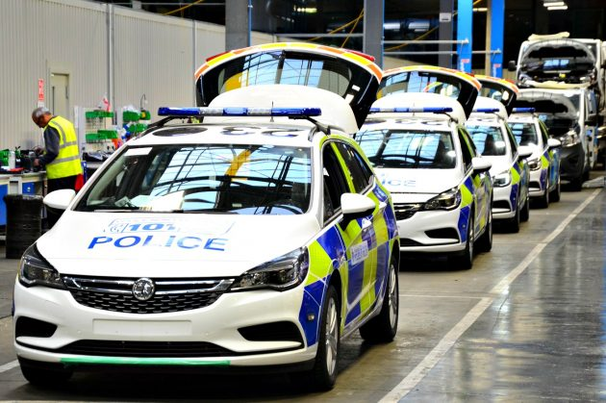
Therefore, in consultation with the force, the Norfolk Federation H&S team assessed which equipment was carried and the force set about replacing equipment with a modern lighter kit.


Road Signage (in vehicles)
The signage that had been issued to police vehicles was not in line with the requirements of Chapter 8 in the government’s official Traffic Signs Manual which relates to ‘Traffic Safety Measures and Signs for Road Works and Temporary Situations’.
Whilst it is not statutory, it is set out in a code of practice that facilitates the legal requirements covered by various legal regulations.
The problem was with the height of the signs, they did not meet the code but after consultation this has now been rectified.

Advice services

29
people attended
FINANCIAL SURGERIES
Provided by Alan Boswell & Co

24
people attended
MATRIMONIAL SURGERIES
Provided by rogers & norton

36
people attended
MORTGAGE ADVICE
Provided by Mortgage excellence plc and Forces Financial

Financial summary | 2016 | 2017
Total income | £140,669 | £146,967
Total expenditure | £125,890 | £139,419
Net assets | £595,834 | £119,428

DEBT ADVICE
referrals made to
Funding and financing
The Norfolk Police Federation Branch keeps 30 per cent of the subscription funding from its members in order to run the local branch. The remaining 70 per cent goes to Federation HQ where requests for legal assistance are processed in accordance with fund rules. The Norfolk branch finances are supplemented by income from member services which are administered by the office staff.
The majority of subscriptions nationally go towards legal costs in supporting members with work-related issues. The figure during 2017 was over 80% of revenue is spent on legal costs.
The major cost locally is for our experienced staff who provide an excellent service covering the office, answering members’ queries, arranging meetings, courses and retirement seminars, negotiating with the Force, carrying out research, administering member services and generally supporting the representatives.
Expenditure is overseen by the treasurer and there are three trustees who dip sample and check the accounts. The accounts are also audited by professional chartered accountants.
Conference costs are down as we have reduced the number of representatives attending to make savings. This also reduces the cost to the Force. Donations to worthy causes have increased as the Branch Board has authorised contributions towards the Police roll of Honour Trust, the national Memorial Arboretum and to funds supporting the families of colleagues who have died throughout the country.

(Figures not recorded)
The Norfolk Police Federation branch has, over many years, carefully managed its expenditure and made savings every year to build up reserves. Some of these reserves are in the asset of our new office premises to invest in secure and stable bricks and mortar.

Branch expenditure 2017

EXPENDITURE
 | 2016 | 2017 | + or - £200
Accommodation | £5,243 | £5,318 | even
Additional Responsibilities Pay | £3,993 | £9,222 | plus
Annual Conference | £1,084 | £770 | minus
Audit/Accountancy | £3,228 | £3,682 | even
Bank Charges | £231 | £302 | plus
Clerical/Staff Costs | £66,895 | £84,425 | plus
Telephone | £1,639 | £1,815 | even
Computer Consumables | £5,336 | £4,665 | minus
Corporation Tax | £337 | £617 | plus
Depreciation: Computers | £4,478 | £4,660 | even
Donations | £0 | £1,600 | plus
Federation Diary | £2,996 | £1,302 | minus
Incidental Overnight Expenses | £385 | £170 | minus
Insurance *including NPF office cover | £1,456 | £1,603 | plus
Legal and Professional | £2,760 | £2,409 | minus
Medical Expenses | £3,516 | £0 | minus
Meeting Expenses | £4,646 | £3,845 | minus
Postage, Printing, Stationary | £3,642 | £1,644 | minus
Subsistence (Meal) Expenses | £1,708 | £1,431 | minus
Sundry Expenses | £1,218 | £1,827 | plus
Training | £3,428 | £4,950 | plus
Presentation & Gifts | £584 | £0 | minus
Travel | £7,067 | £8,112 | plus
TOTAL | £125,870 | £139,419 | plus

Additional spending during the 2017 period related to;
- Training of new representatives
- National ARP (Honoraria) payment – gross amount
- Staff Costs for covering the sickness absence and during a resignation.

Other events of note 2016

JANUARY FEBRUARY MARCH

Competence assessment for constables pay point 4
A constable approaching pay point four (usually towards the end of their third year in policing) undertake an assessment, rather than 'automatically' progressing up the pay scale based on time served. ARC is to run alongside the Continuing Professional Development.
Police Federation survey finds 82 per cent of officers who responded said Taser should be issued to front line officers’
Keith Palmer GM Police Officer Metropolitan Police died 22nd March 2017, aged 48 years. Whilst tackling a terrorist armed with two knives that had entered the Palace of Westminster, Keith sustained fatal stab wounds prior to the attacker being shot by other officers.

JULY AUGUST SEPTEMBER

Bravery awards, the region nominee PC Jo Jermy saved a teenage girl from falling from a motorway bridge. The officer and his colleague discovered the 15-year-old balanced on a flyover on a main road in Dereham with a railway line some 20 feet below. The girl had climbed over the barrier and was standing on a ledge. She said she wanted to be with her dead mother.

PC JERMY at 10 Downing St.
New police welfare fund great news for over-stretched cops
Officers will benefit from a new £7.5m welfare fund after the Police Federation lobbied the Government tirelessly for the police service to have more help.
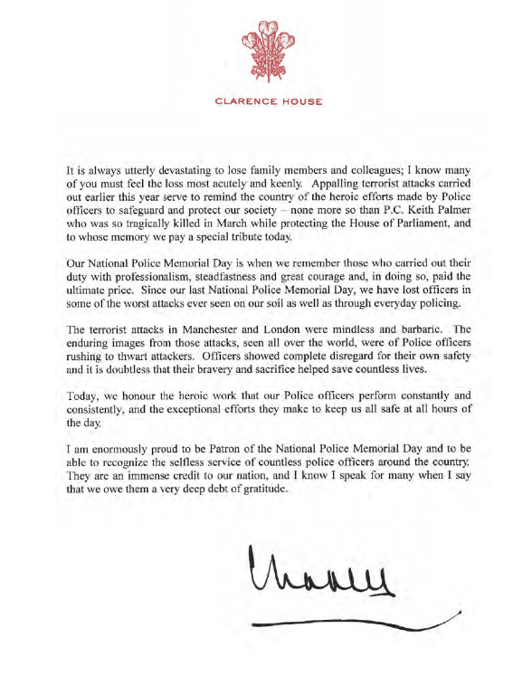
The National Police Welfare Service will initially be tested as a pilot. PFEW will continue to work with stakeholders to ensure that the scheme is a success.

14
National Police Memorial Day honours the valour and sacrifice of almost 4,000 police officers from the UK police forces.
Police officers of all ranks join the families of fallen officers at St Paul’s Cathedral in London for the annual service.

APRIL MAY JUNE

HMIC report states "We cannot realistically expect the police to meet every possible demand we might make of them," said Sir Thomas Winsor.
The Federation supports Sir Thomas' call for mental health funding to receive the same priority as physical health. The federation states that policing is filling the gaps created by other agencies.
Police Federation annual conference in Birmingham – attended by Sir Tom Winsor, head of HMIC, the chairman of the national Police Chiefs’ Council (nPCC), the chief executive officer of the College of policing and the Home Secretary to name a few.

The Manchester terror attack, where off-duty Cheshire officer Elaine McIver was among the 22 victims and over 100 more people injured. The Prime Minister Theresa May ordered soldiers onto the streets to assist police, freeing officers up to concentrate on the fight against terror.

OCTOBER NOVEMBER DECEMBER

Norfolk Police Officers are deployed to the British Virgin Islands.


Police Federation’s national Detectives’ Forum (PFnDF) Awards recognise Britain’s elite detectives.
Training is provided for representatives during Continuous Professional Development (CPD) arranged by Norfolk Police Federation.

New Regulations issued to the Federation, a fundamental change in the way the Police Federation operate is started when new regulations were laid in parliament.
Police Pursuits, at the annual Roads Policing Conference, Mark Aldred (Barrister) said that pursuit drives fell squarely into the definition of ‘dangerous or careless driving’ and it was important all officers made themselves familiar with the law. “If we are going to ask officers to do this job, we need to make sure they are protected. The courts have made it clear that in assessing whether a drive was dangerous, the officer’s skill and training are to be disregarded.”



15

Workplace representatives for 2017 All workplace representatives are members of the Branch Council
Other roles
Mental health First aid trained
ASM
trained
Discipline trained
Board H & S Grievance Equality PIP member trained trained trained trained
Location
Rep
Norfolk Police Federation, 43 Thorpe Road, Norwich, Norfolk NR1 1ES Telephone: 01603 971420 Email: norfolk@polfed.org

equality lead, H & S deputy Deputy secretary
Andy Symonds  Chair | OCC | l | l | l |  | l | l | l | l |  | CAPlO
Keth Bristo  Secretary | OCC | l | l | l | l | l | l | l | l |  | Treasurer
Sam Hawkins | OCC | l |  | l | l | l | l | l | l |  | equality lead
Shane Schucroft | OCC | l | l |  |  |  |  |  |  |  | H & S lead, roads policing lead  uniform and standards deputy
Adam Edge | Sprowston | l |  | l | l | l | l | l | l |  | Custody deputy
Andy Guy | OCC |  |  |  |  |  | l |  |  |  | CID lead
Nick Cheshire | Great Yarmouth | l |  |  |  |  | l | l | l |  | Vice chair, discipline deputy, PST deputy,
Andy Smith | Kings lynn | l |  | l | l |  | l | l |  |  | Constables lead
Steve Godden | Hurricane Way |  |  |  |  |  |  |  | l
Rob Devlin | Aylsham |  |  |  |  |  | l
Andy Bithell | Acle |  |  |  |  | l |  |  |  |  | Firearms lead
Rob Curl | Kings lynn | l |  |  |  |  | l | l | l |  | Custody lead  ethics Committee lead
Brain Sweeney | Aylesham | l |  |  |  |  |  | l | l
Gareth Woodward | Dereham | l |  |  |  |  |  |  |  |  | Professional development lead,
Kevin White | north Walsham |  |  |  |  |  | l | l
Jo Minnis | Bethel Street |  |  |  |  |  |  | l | l |  | uniform and standards lead,
Terry Lordan | Thetford |  |  |  |  |  |  |  |  |  | reserve member
Lee Wilson | Hurricane Way | l |  | l | l | l | l

ethics Committee deputy

PST deputy

Professional development deputy

