**Fallbarrow Park - Abi Ambleside Caravan**

North Yorkshire Police Group Insurance Trust have updated the caravan on its existing pitch at Fallbarrow Park with a new Ambleside static caravan.

Featuring a fully fitted kitchen which has a built-in oven and hob as well as an integrated fridge freezer. It also has an integrated dishwasher and a built in microwave.

There is a dining table with 4 chairs and a relaxing lounge with 2 comfortable sofas (one of which is a pull out sofa bed), TV and an electric stove.

The main bedroom hosts an en-suite bathroom, has a comfortable king size bed and there is an additional “house” bathroom.

Ideal for smaller families and couples - comfortably sleeps up to 6 people.

Alongside the double and twin bedrooms, there is room for two extra guests with a pull-out sofa bed in the lounge.

With its plush interiors, a fresh colour scheme and a whole host of practical necessities, this stunning caravan is designed to perfection and offers a true home from home experience.

Our members are permitted to take dogs to this property.

Photos for your perusal….

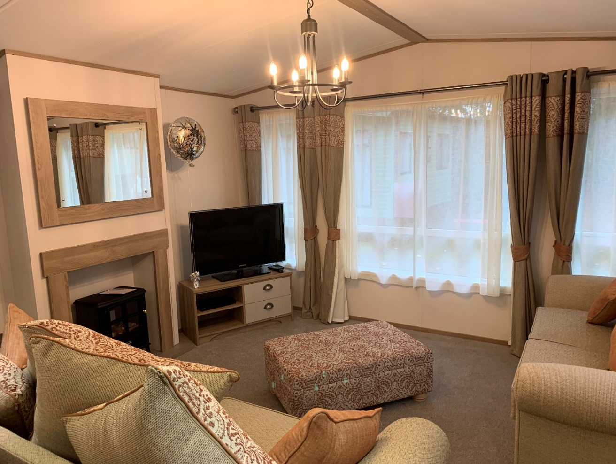

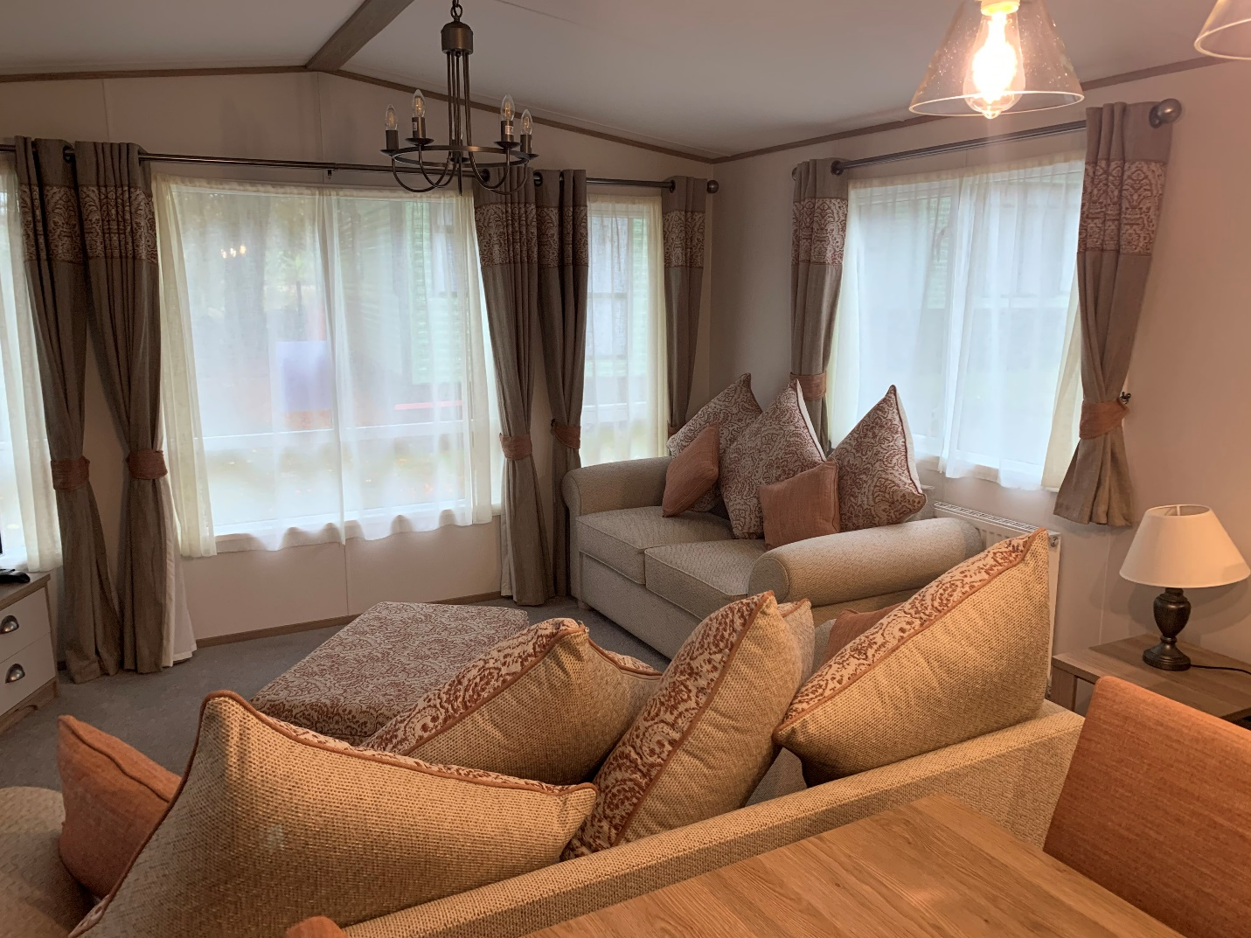

Living Room

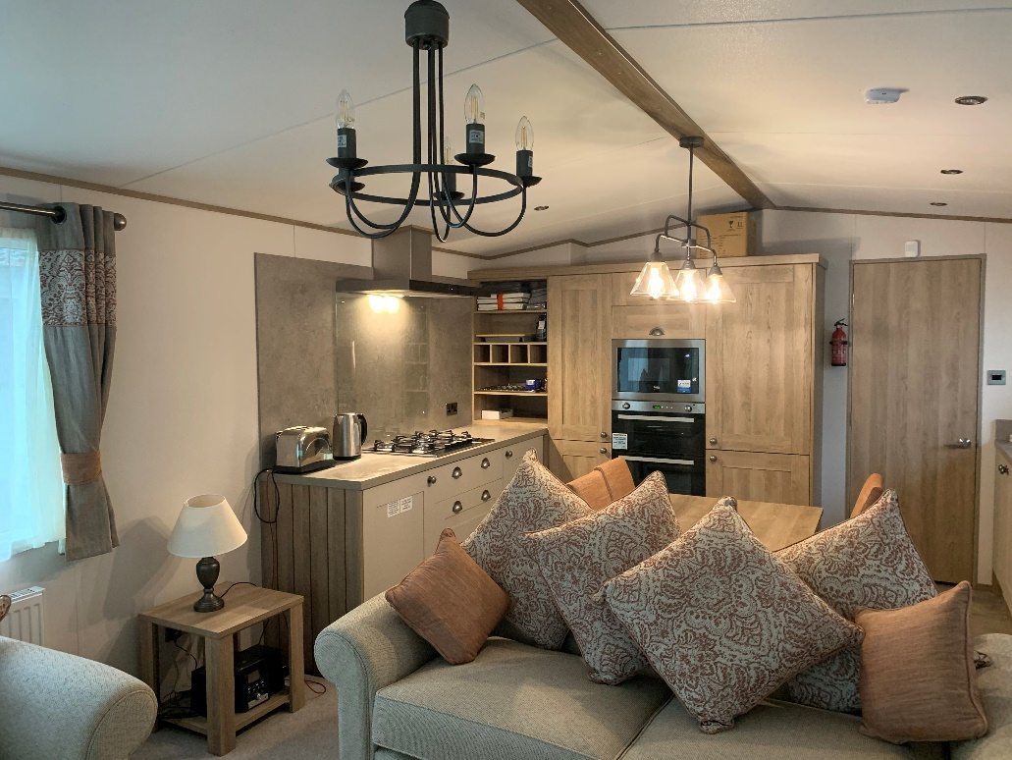

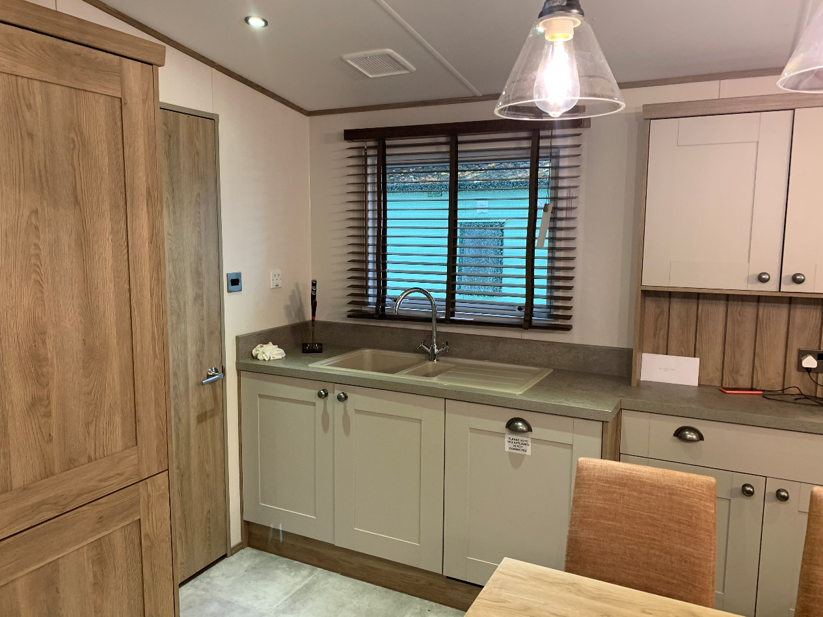  
Kitchen/Dining area

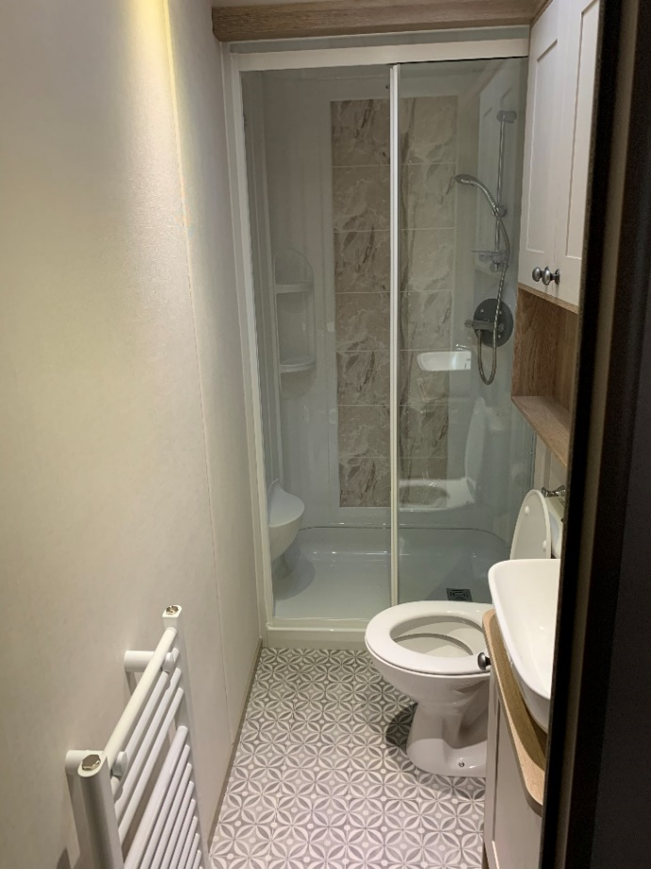 House Bathroom

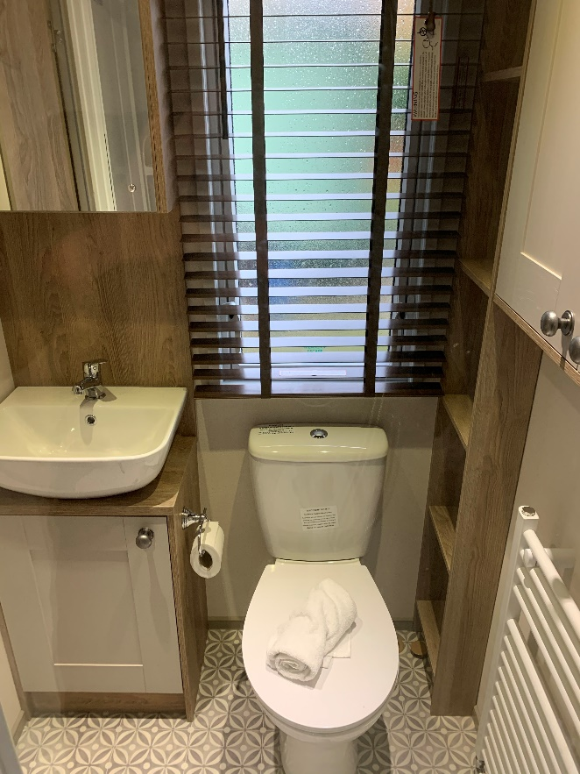

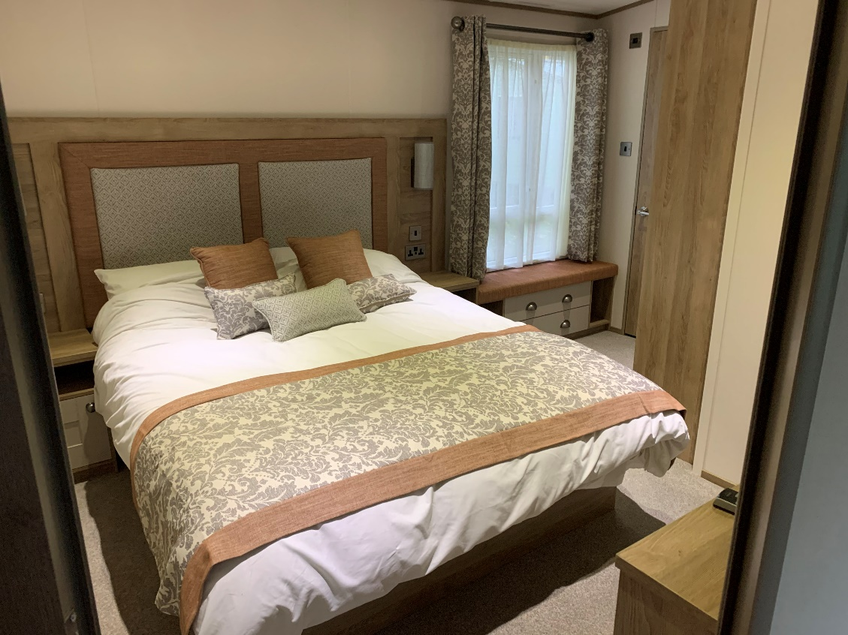

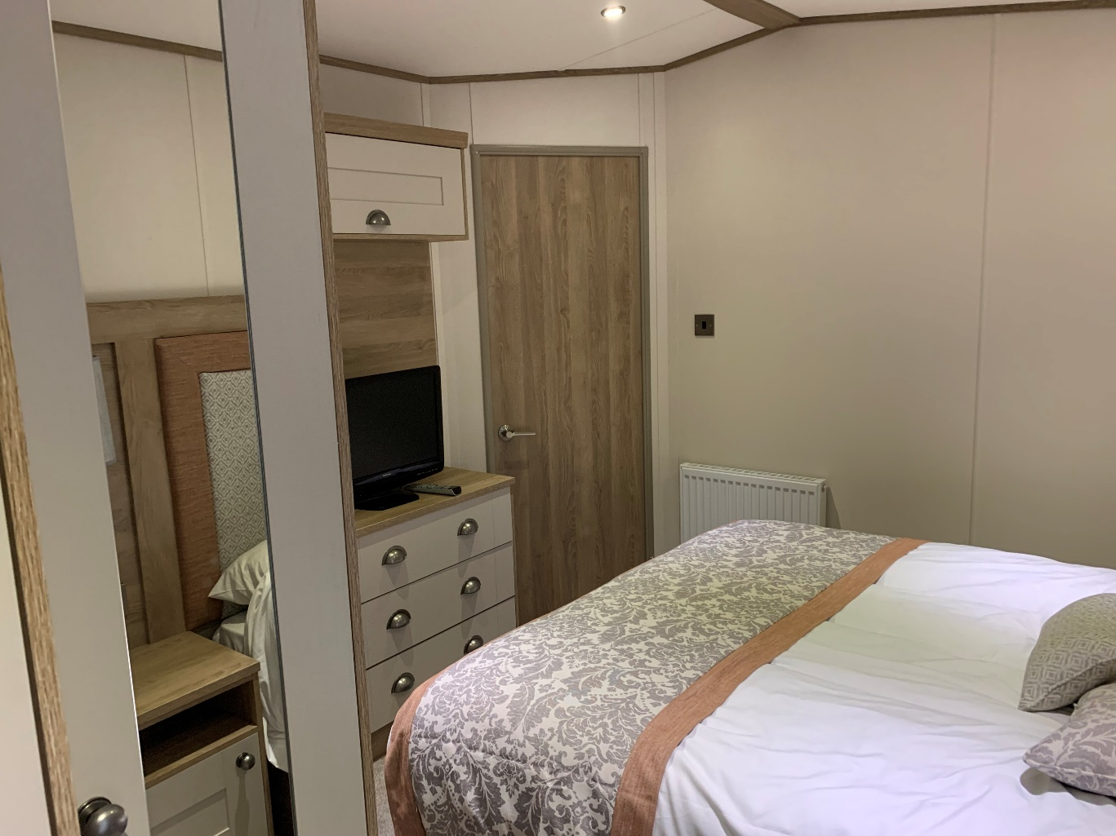Main Double Bedroom

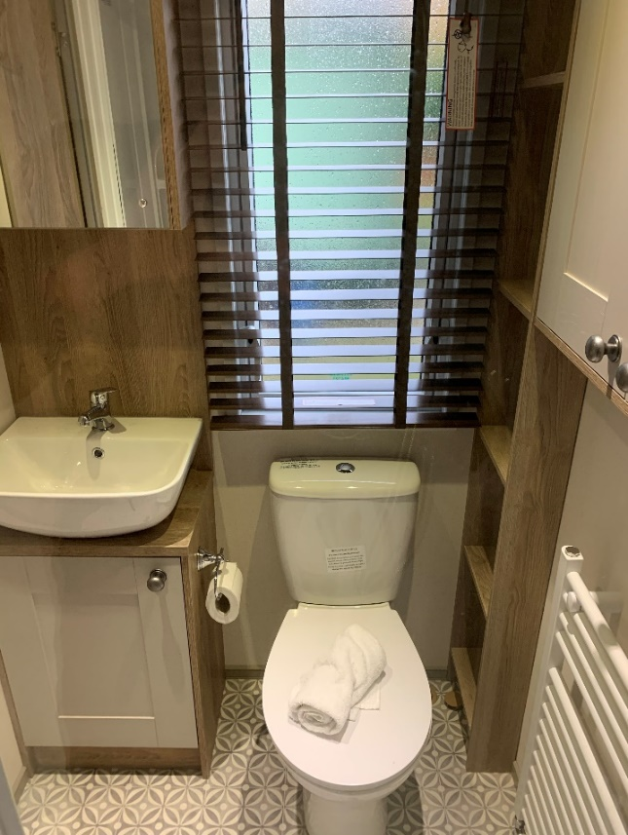

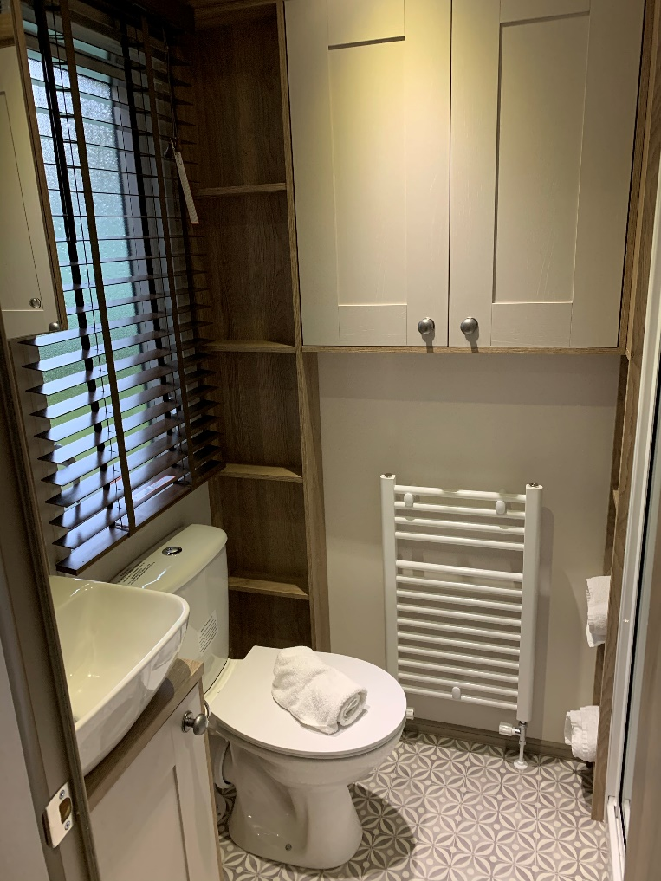

En-suite bathroom

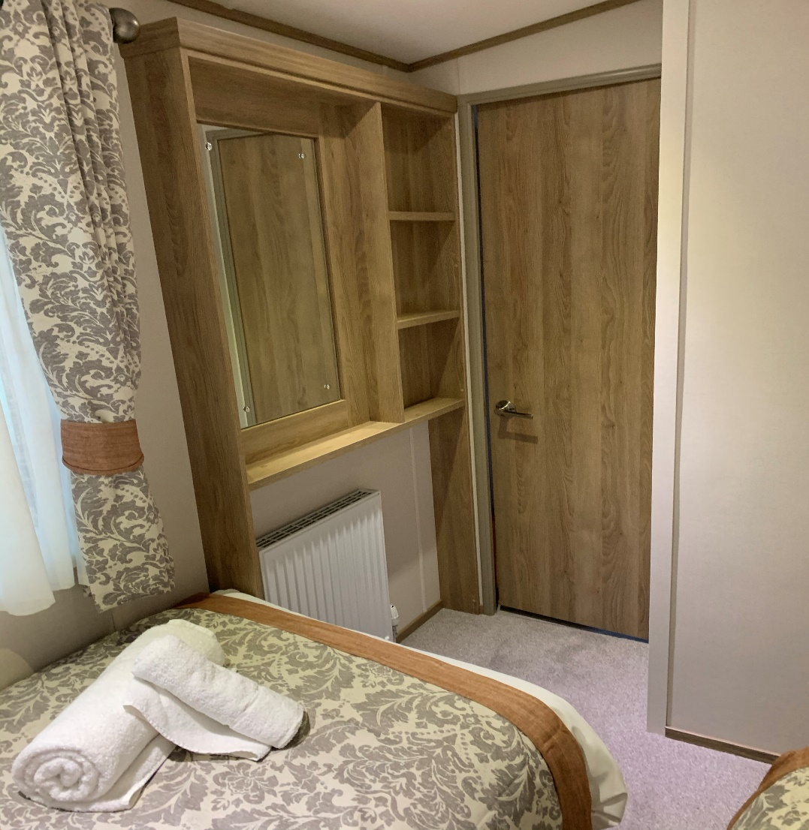

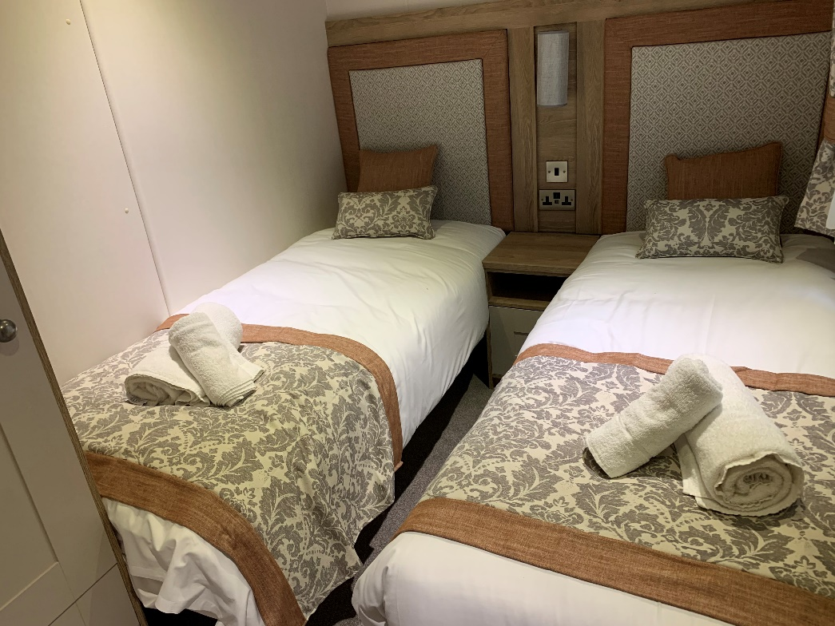

Second (Twin) Bedroom

Ambleside Caravan – with enclosed decking area



