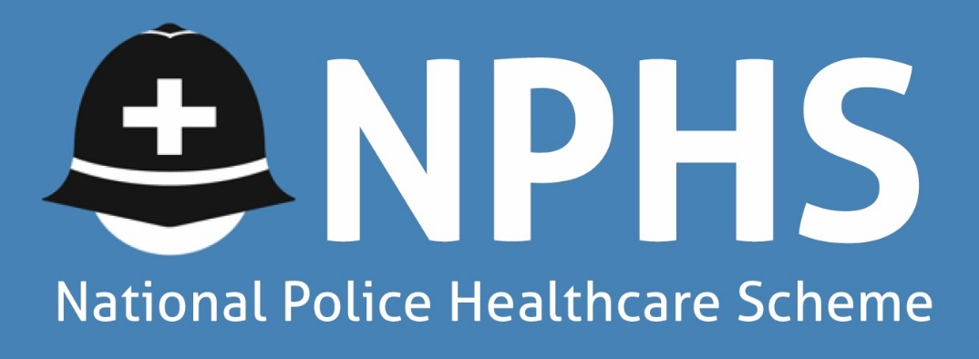

11-14 Apex Business Park, Annitsford, Cramlington, Northumberland NE23 7BF
Tel: 0191 4373000 Email: healthcare@npf.org. Website: www.norpolfed.org
VAT Reg No. 993179764

Date as Postmark

Dear Colleague

Re: The National Police Healthcare Scheme – Student Officers

Following receipt of your application form we are pleased to confirm that you are now a member of the above scheme. You will receive free membership for the first 12 months from the date on which you joined as a Student Officer. However, if you wish to cover your spouse/partner and any dependent children under the age of 21, then you will be required to pay subscriptions for them (see second page of this letter).

With regard to cover, any new conditions will be covered with immediate effect. Benefit is not payable during the first 24 months of membership for any pre-existing conditions.

Please find below further information in respect of the scheme:-

1. Any provider can be used as long as they are a recognised and accredited healthcare provider but of course subject to cost and on the agreement of the trustees as with all current treatments.

2. All forms of chemotherapy, radiotherapy and associated procedures will be excluded.
3. The NHS Cash Benefit will be paid for day-case surgery performed as a patient on the NHS as well as overnight stays in hospital as an NHS patient. The rate is £100.00 per day or overnight, subject to an overall maximum cash benefit to any one member of £2,500 in any twelve-month period. Claim forms must be returned within 14 days of discharge. Emergency admissions are exempt.

4. The cost of physiotherapy, osteopathy, chiropractic and acupuncture treatment received as an outpatient is payable at £200.00 per course. The overall limit for this type of treatment would be two courses per condition per year. In addition, the fund will pay for your initial assessment fee but if there are any costs incurred for completion of the form by the GP/Consultant this will be your responsibility.

5. The following subscription rates for each age band apply with effect from 1 July 2019:-

THIS TABLE REFERS TO FIRST YEAR MEMBERSHIP ONLY

Members Age | 18-29 | 30-39 | 40-44 | 45-49
Member Only | Free for 1st Year | Free for 1st Year | Free for 1st Year | Free for 1st Year
Member & Spouse | £ 16.00 | £ 22.00 | £ 27.00 | £ 33.00
Family | £ 30.00 | £ 36.00 | £ 41.00 | £ 47.00
Member & Child(ren) | £ 14.00 | £ 14.00 | £ 14.00 | £ 14.00

THIS TABLE REFERS TO MEMBERSHIP AFTER THE FIRST YEAR

Members Age | 18-29 | 30-39 | 40-44 | 45-49 | 50-54 | 55-64 | 65-69 | 70-74 | 75-79 | 80+
Member Only | £16.00 | £22.00 | £27.00 | £33.00 | £37.00 | £ 46.00 | £ 58.00 | £100.00 | £120.00 | £140.00
Member & Spouse | £32.00 | £44.00 | £54.00 | £66.00 | £74.00 | £ 92.00 | £116.00 | £200.00 | £240.00 | £280.00
Family | £46.00 | £58.00 | £68.00 | £80.00 | £88.00 | £112.00 | £144.00 | £230.00 | £270.00 | £310.00
Member & Child(ren) | £30.00 | £36.00 | £41.00 | £47.00 | £51.00 | £ 66.00 | £ 86.00 | £130.00 | £150.00 | £170.00

6. Following their 21st birthday, a child can remain in the scheme at the rate of £16.00, which will apply in the month following their 21st birthday. This applies until they reach the age of 30, at which point their payments will increase in accordance with the current age-related subscriptions.
If you require any further information, please do not hesitate to contact the Scheme Administrator on 0191 4373000.

Yours sincerely

Branch Council Chair

On behalf of the Trustees of
The National Police Healthcare Scheme

