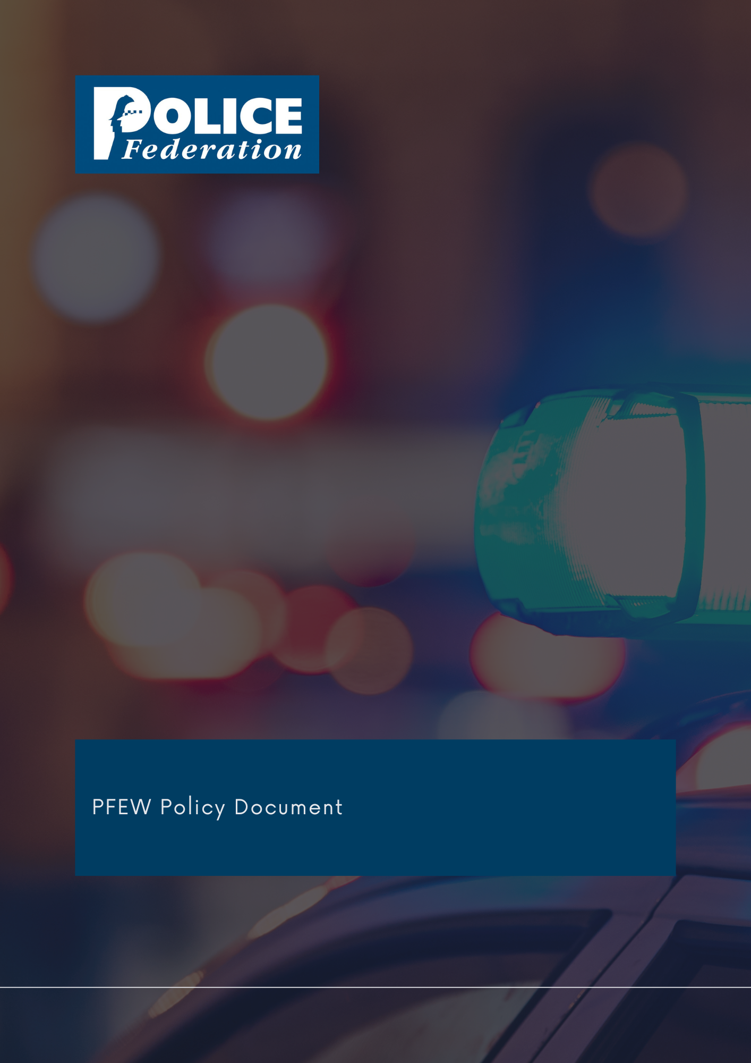
Roads Policy

Version 1
2023

The PFEW Policy Department has embarked on a programme to formulate and revise policy documents on matters of particular importance to its members.

It is the aim of PFEW to maintain clear policies on key topics that allow members to understand PFEW's official position on those areas.

These strategic documents are evidence-based, aligned with PFEW's Business Areas and championed by National Board members.

If you have any comments or queries, please direct them to Bahar.Munim@polfed.org

ROADS

1. Policy statement
According to official Government statistics for 2021

- there were an estimated 1,390 reported road deaths in 2021, a decrease of 11% from pre-pandemic levels (2019)
- a rate of 5.2 fatalities per billion vehicle miles in 2021, a higher rate compared with 2019 and a lower rate compared with 2020
- an estimated 27,450 killed or seriously injured (KSI) casualties in 2021, a decrease of 11% compared to 2019, with a casualty rate of 91 KSI per billion vehicle miles, a similar rate compared with 2019
- an estimated 128,209 casualties of all severities in 2021, a decrease of 16% compared to 2019, with 425 casualties per billion vehicle miles, a lower rate compared with 2019.
- 15% of road deaths (2020 figures, as 2021 not yet published) in England AND Wales were attributed to drink driving.

Aside from deaths and injuries, the road network is the conduit for a whole host of criminal activity which has serious implications for society as a whole.

Roads policing is far more involved and complex than dealing with motoring offences, important though these issues are for public confidence and road safety. We need to look at the whole package of how we deliver a strategic roads policing programme to a consistent national standard. Through enforcement activity of current legislation, education of road users and monitoring of driver behaviour, proactive targeting to deny criminal use of the road network and investigation of collisions involving death and serious injury, police officers of England and Wales are at the forefront of road safety and should remain so. The recent decline in deaths and collisions resulting in serious injury are encouraging and are in no small part due to the activity of police officers up and down the country. PFEW fears however that the decline in roads police officer numbers could undermine this trend and would like Chief Constables to prioritise staffing in RPU departments.

2. Responsibility
The National Board is responsible for all policy formation.

3. Summary
PFEW believes that the essential role of roads policing within the overall policing portfolio should not be underestimated, nor should the extent of criminal activity and use of the road network to facilitate criminal behaviour. Roads policing has suffered more than most with cutbacks, and this will impact on the ability of the Service to protect the public. The often complex and technically challenging road traffic laws require enforcement by police officers that are skilled and trained to a suitably recognised national standard with proper continuing professional development. We believe training needs more investment and we will continue to work to achieve more training, awareness and support for officers, especially in light of the recent legislation change, which focuses on Police drivers being up to date in training to be afforded protection in law. This will ensure that the public receives the highest level of professional competence. In order to police the roads effectively and meet public expectations, our operational resilience and capacity to deliver to a good standard, in terms of people, equipment and technology, needs to be maintained at a level commensurate with demand.

PFEW recognises that road casualties are declining year on year and this is good news. However, there are still four deaths per day, on average, on Britain’s roads and there is no room for complacency. We especially recognise the risks posed by young drivers. We strongly advocate national standards and consistency in order to deliver a professional roads policing service throughout England and Wales. PFEW supports force collaboration in making the best use of resources to deliver a first-class service which has a positive impact on people’s lives locally, regionally, and nationally. We will continue to monitor Blue Light Commercial, the Government procurement framework for the standardisation of police vehicles and technology. In terms of technology, it is essential that the equipment available to our members enables them to deal with incidents effectively in order to minimise road closures and disruption to the public. Exploiting technology is essential for gathering evidence. PFEW robustly supports the enforcement of legislation in relation to drink / drug driving, anti-social behaviour, excessive and inappropriate speed, mobile phone use whilst driving and failure to comply with seat belt legislation. These irresponsible actions can result in tragedy, and we encourage the targeting of motorists who flout the rules of the road.

There is ample evidence of bad or poorly maintained speed warning signs and PFEW has been for many years in favour of the relaxation of Government rules to prohibit reminder or repeater signs on certain types of 30mph road. We also believe that better maintained signing and road markings, with improved local authority commitment to their responsibilities, can significantly improve road user behaviour and compliance.

It has been PFEW’s position for many years that smart motorways are dangerous for the public and those who police them. While we welcome plans to cancel all new smart motorways, we will continue to work with Government departments to ensure right decision is made.

4. Procedures/implementation
Through the Operational Policing Group, PFEW will work with the College of Policing to set roads policing standards that are clear and consistent across all forces. We will work closely with the College, and with the NPCC, HMIC, IPOC and the Highways Agency to ensure our voice remains clear and unambiguous on behalf of roads policing officers. We welcome every opportunity to engage with and influence government, pressure groups, and those at executive level to make a difference to this fundamental aspect of police work. Together, we will deliver improvements that are in the interests of all and keep the public safe. Finally, we will seek to extend our links with European policing colleagues to address broader areas of concern linked to intelligence.

Responsibility for maintaining this policy is delegated to the National Secretary and/or business area.

Approved by National Board: June 2023
Review: June 2024 (TBC)

Reported road casualties in Great Britain, provisional estimates: year ending June 2021 - GOV.UK (www.gov.uk)

